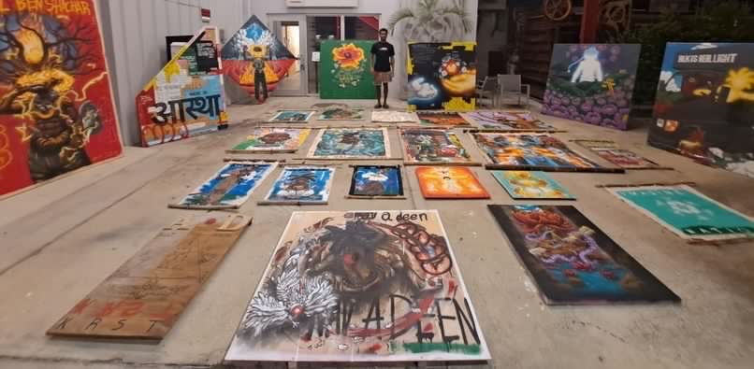
GHETTO GODS Exhibition will be taking place ., August 11, 2023 at studio 620
Located at 620 1st Ave. S., St. Petersburg, FL 33701
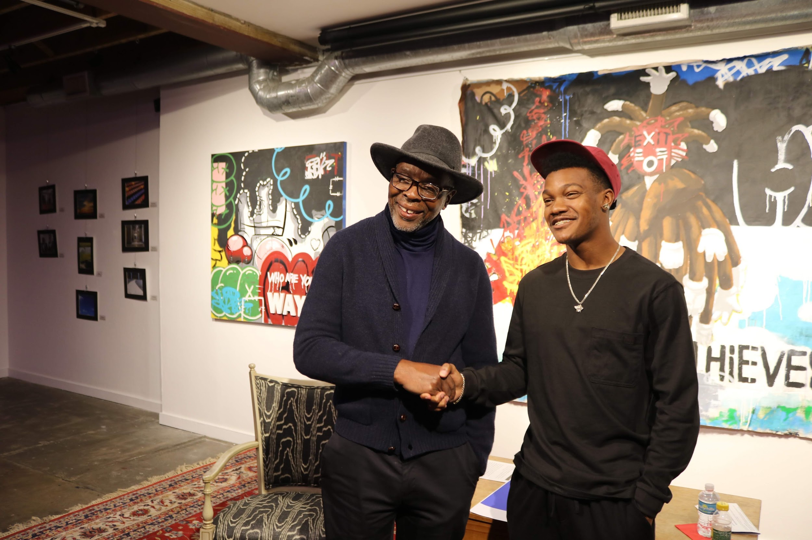
Since I was younger, the topic of religion has always been interesting to me. Always finding myself in debates with my elders on things that just didn’t make sense. As grew, this disconnection with the church allowed me to see other cultures explanation for life and humanity.
Ghetto Gods is a Body of work that I put together to reflect back to myself and illustrate to the world what it is that I actually see as divinity and malevolent in our world.
Due to my agnostic view of the metaphysical my ability to critically think and creatively solve problems has been all but chain down.
Touching on aspects of Buddhism Rastafarianism Christianity Ifá Hebrew Israelites and pure imagination. I have gathered 28 pieces illustrating The forces I encounter on a day-to-day basis and how I see them within other people.
Read more

Please contact me here for inquiries or for more images/ videos of details.
Thisisiboms@gmail.com
7275206834

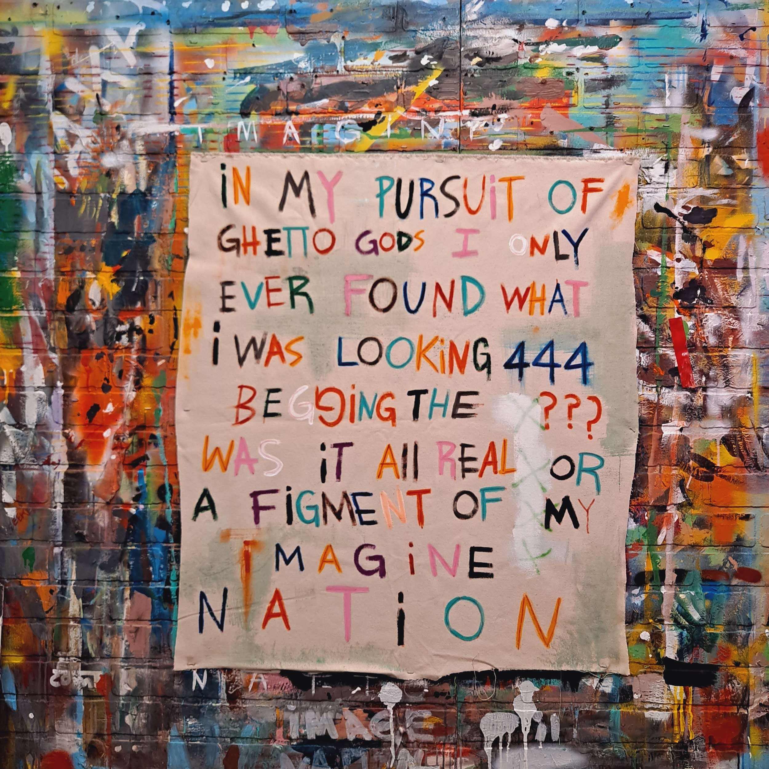
Psychonaut (Journal entry #1)
31x35
$500

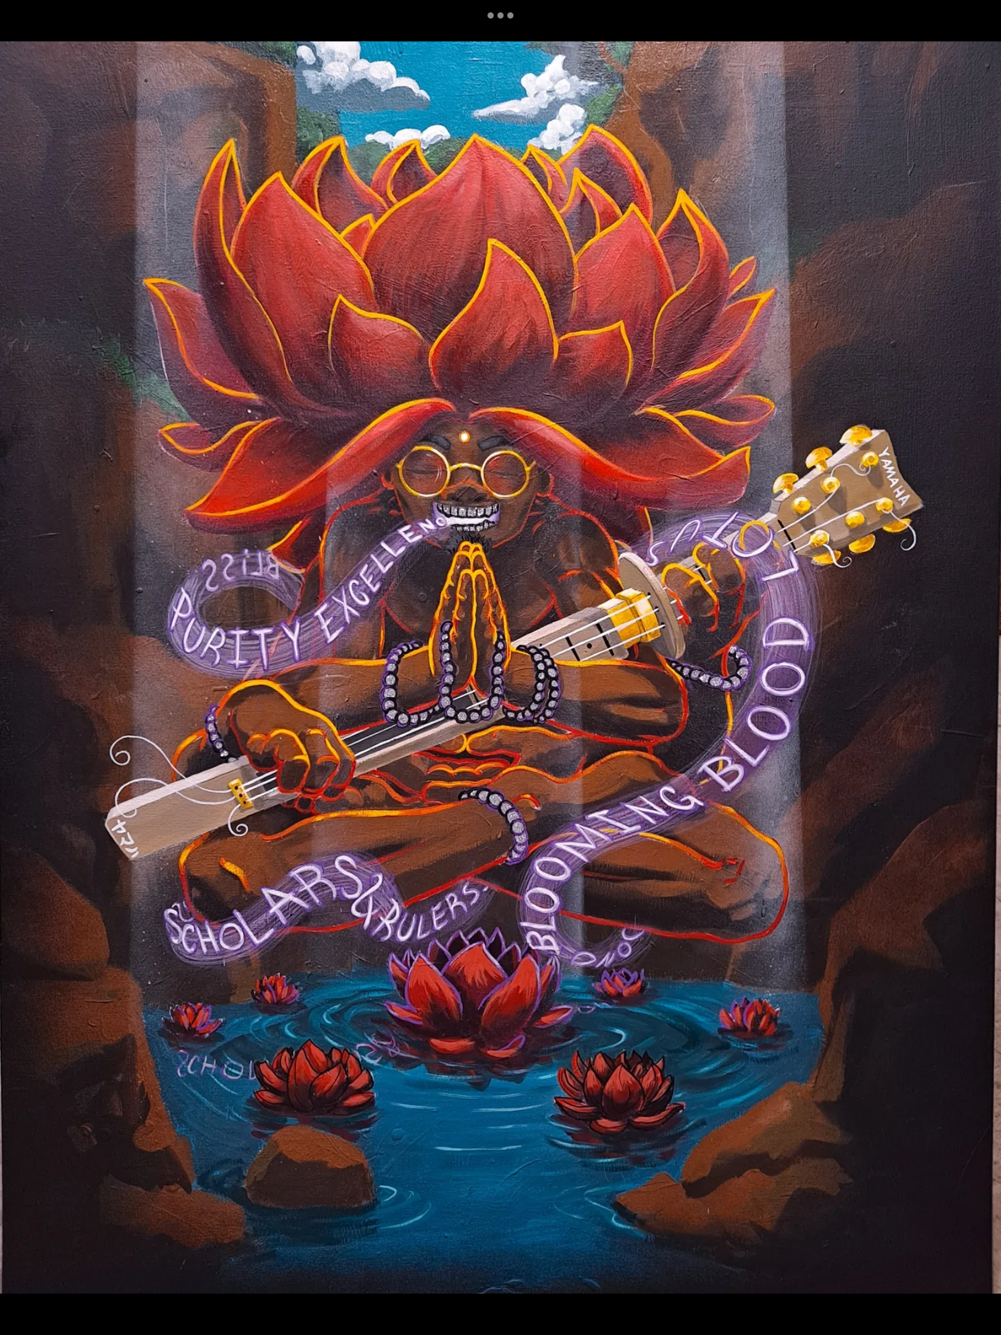
Blooming Blood Lotus
36x48
N/A
"I'm the Lotus Blooming through the mud, fueled by blood(the pains and struggles of life). The EP deals with the final aspect of shadow integration and self actualization, through the Battling of Lucy and the reconditioning of the mind, to finally uncover our true potential. Sun Soldiership is that commitment to uncovering the true potential that lies in our being."
-Ahrod Music

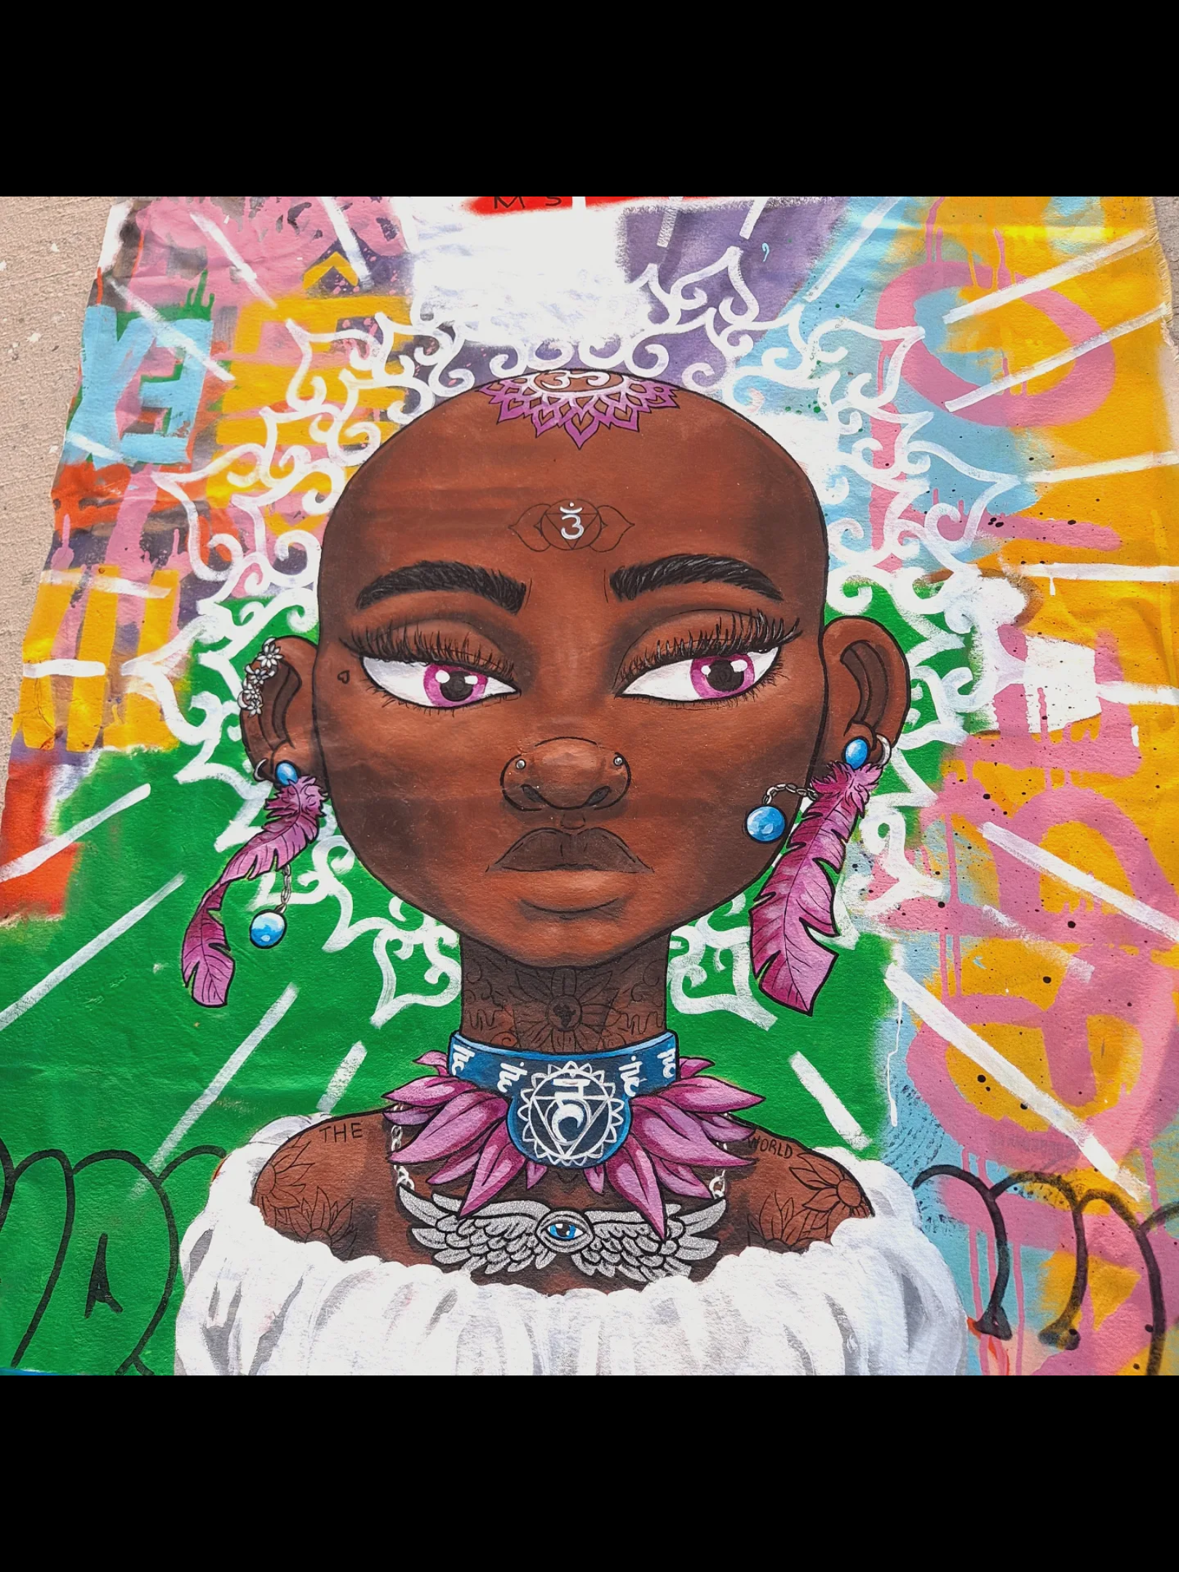
Siobhan (God is Gracious)
36x43
N/A
“It’s more to me than what you see just open up your eyes.
I’m more than fantasy sexuality I can open up your mind.”
-Siobhan Monique

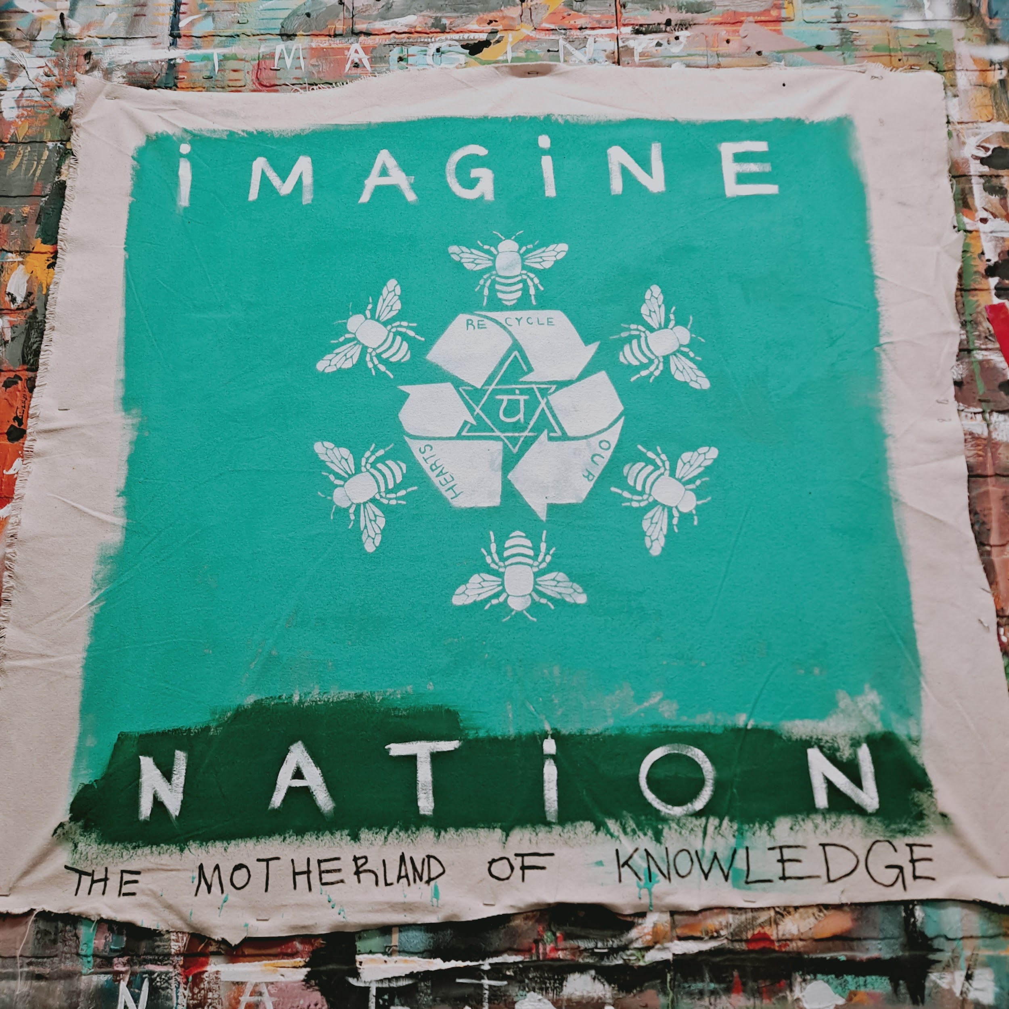
Imagine Nation
34x35
$700
Imagine Nation - Creative Pinellas

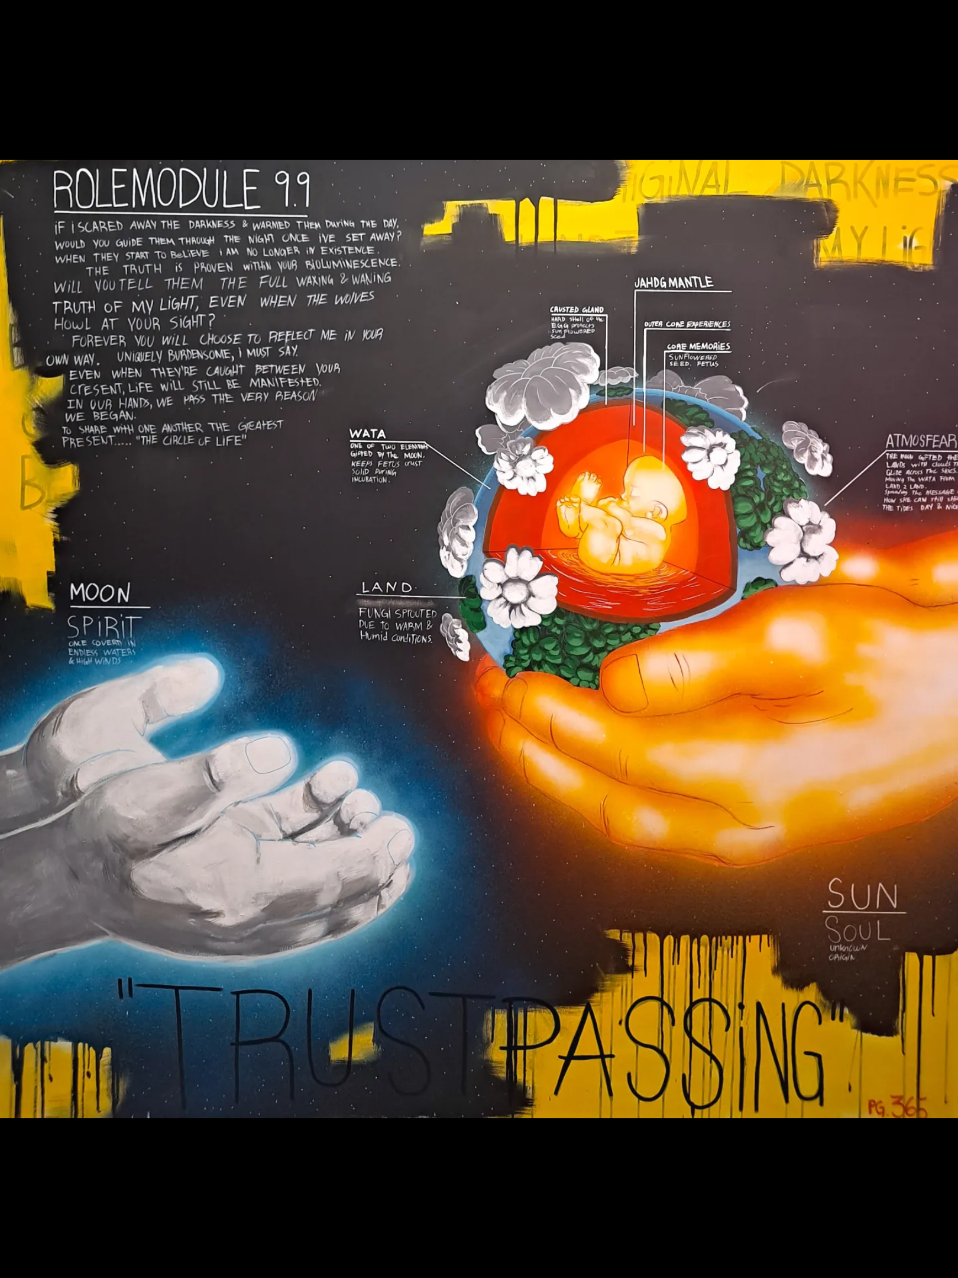
Trustpassing
60x60
$8200
"Core Memories"
If I scared away the darkness and warmed them during the day.
Would you guide them through the night once I've set away?
When they start to believe I am no longer in existence.
The truth is proven within your bioluminescence.
Will you tell them the full waxing & waning stories of my light, Even while the wolves howl at your sight?
Forever you will choose to reflect me in your own way.
Uniquely burdensome, I must say.
Even when they're caught in between your Cresent, life will still be manifested.
To your hands, I pass the very reason we began.
To share with one another
the greatest present.
Trustpassing - Creative Pinellas

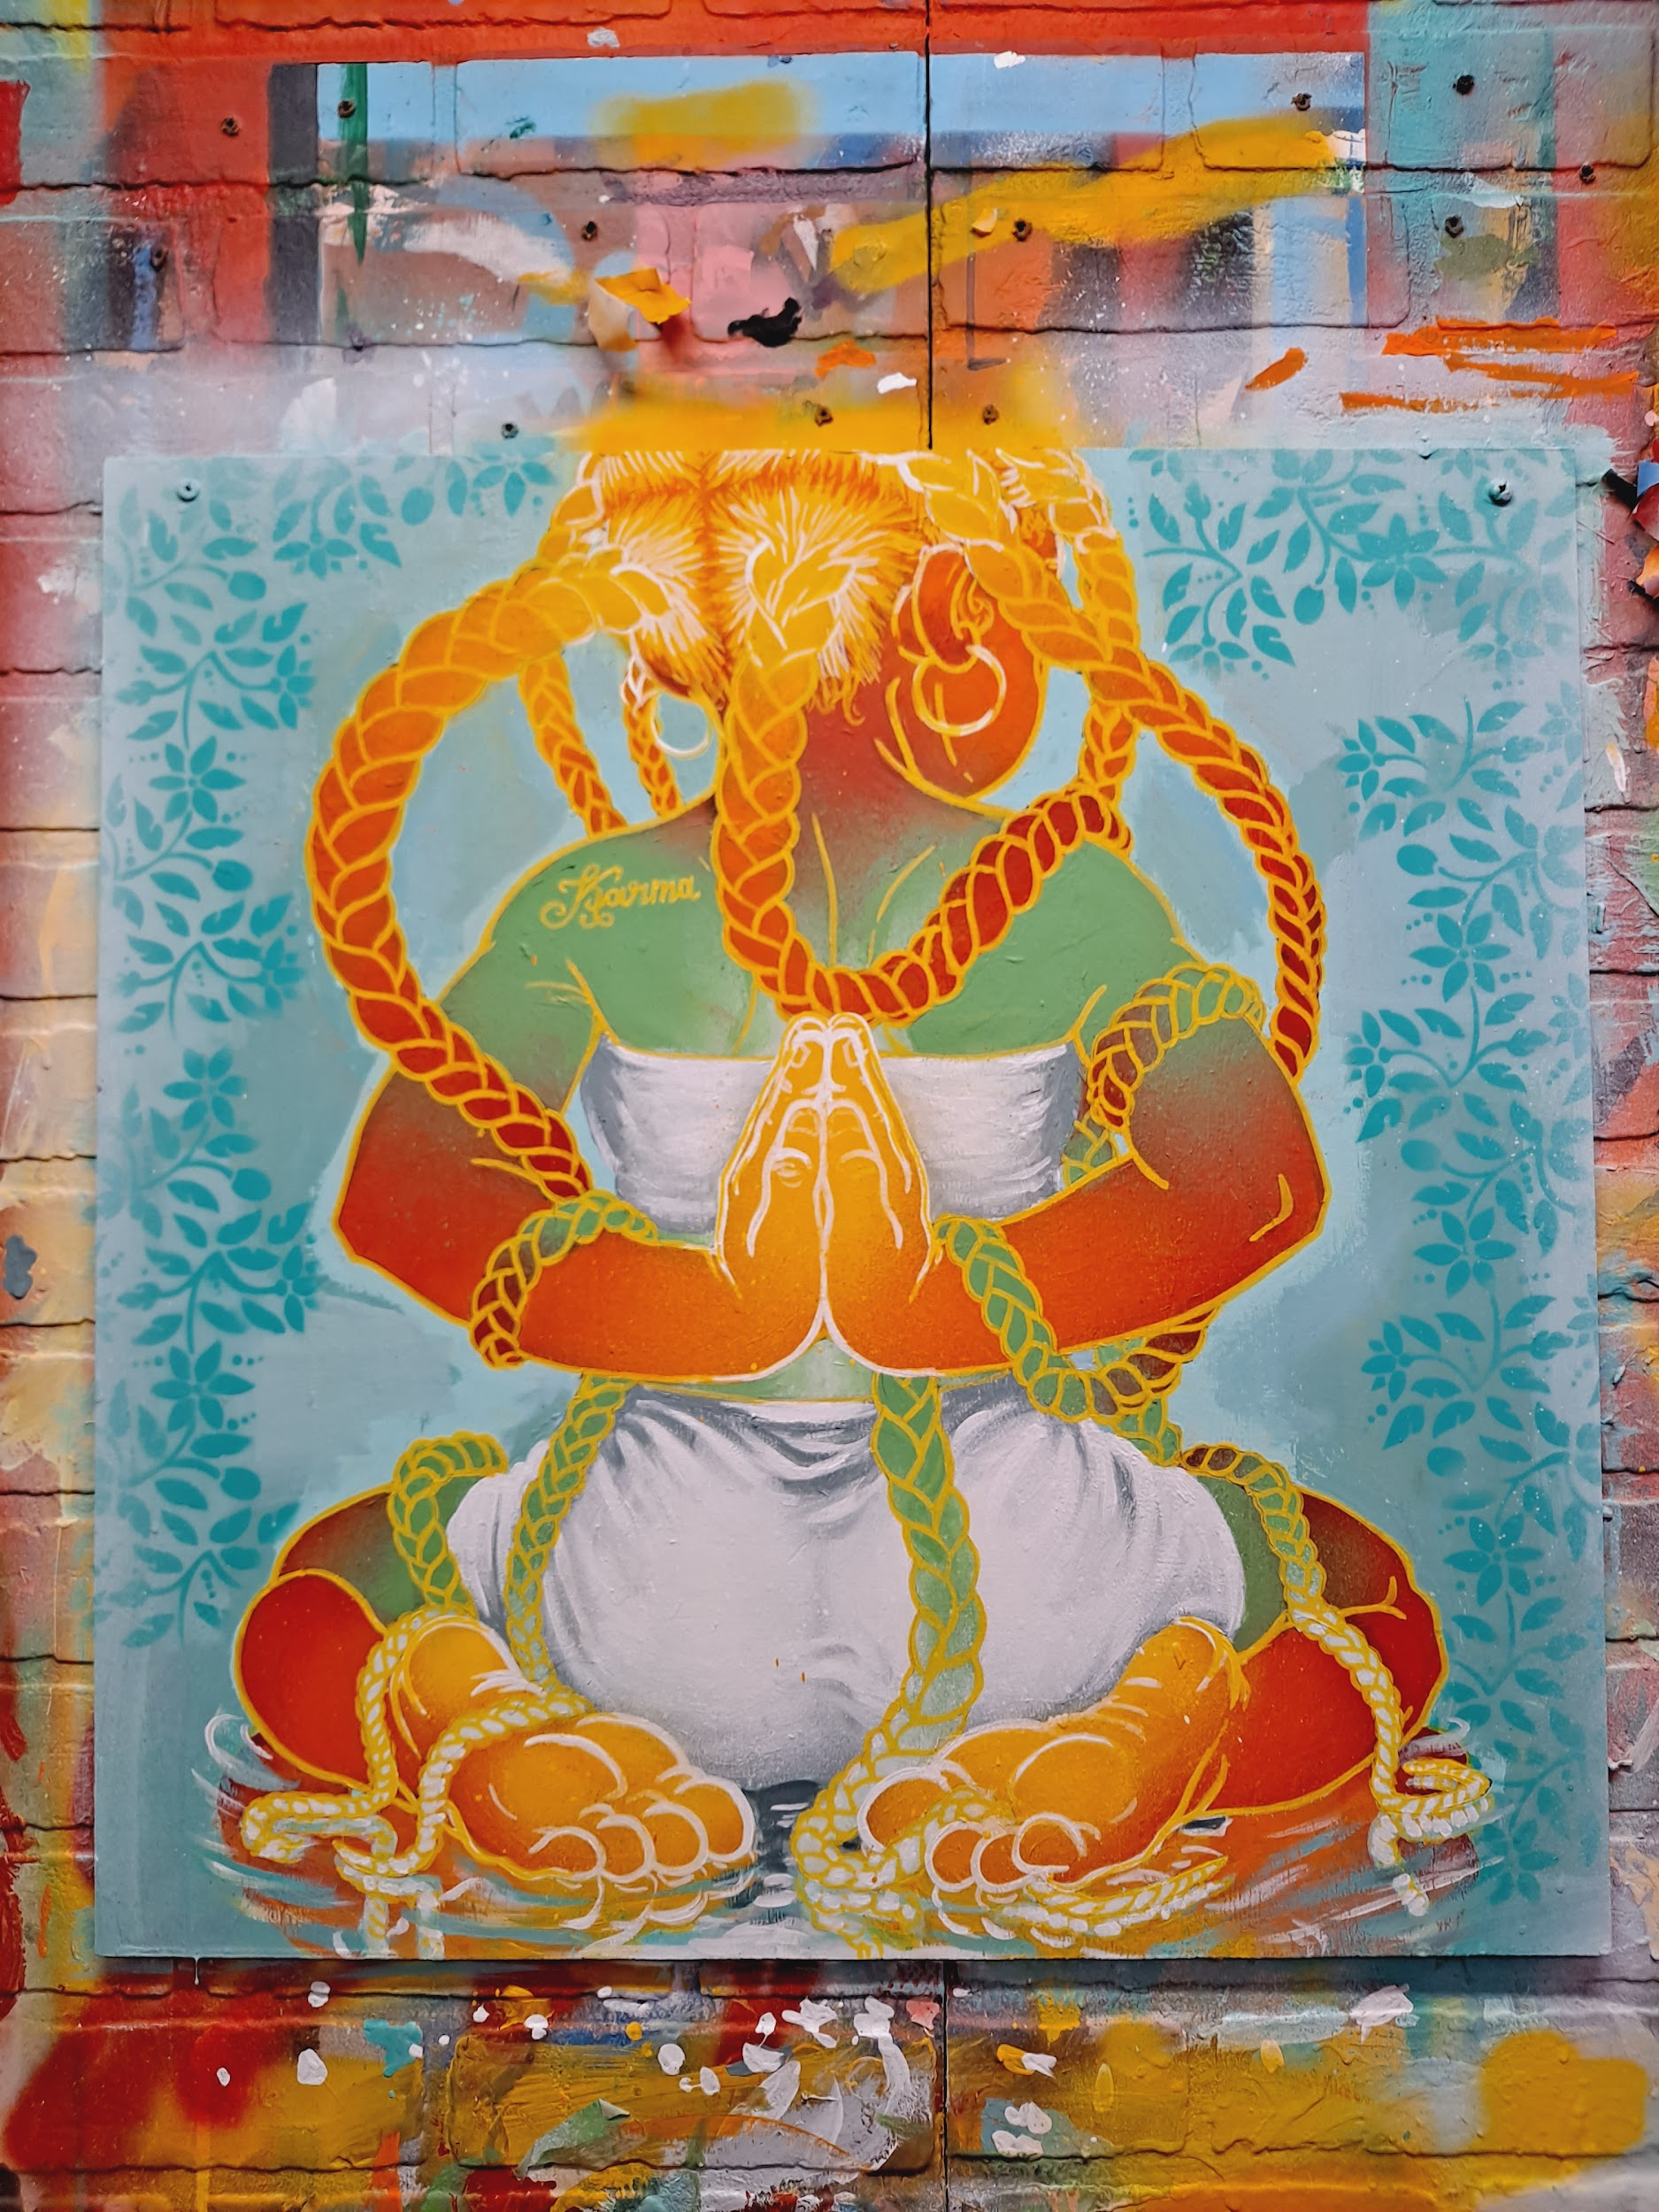
The girl who forgot her name was (Karma)
24x24
$1200

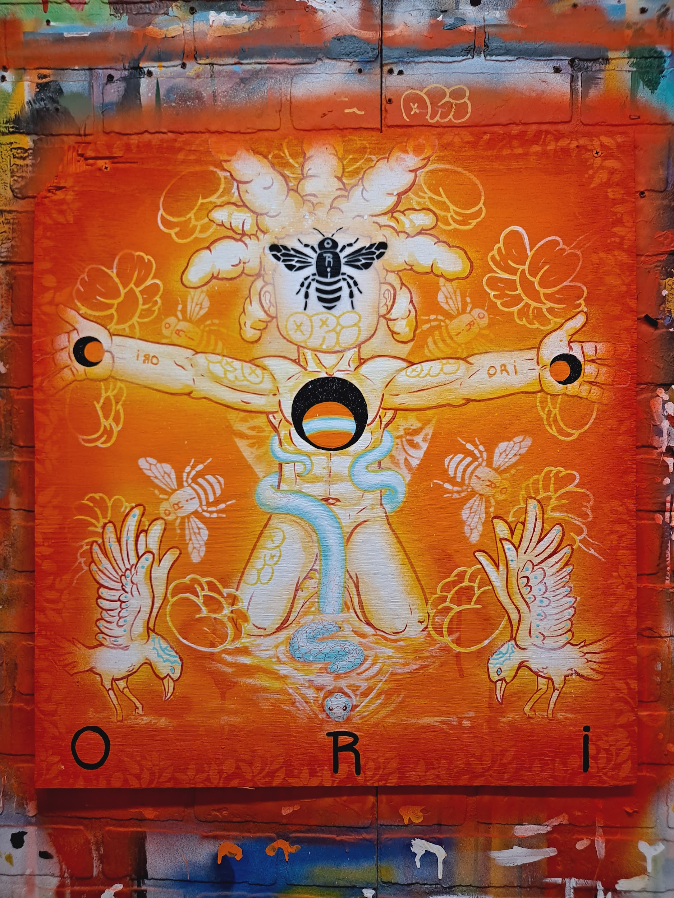
Ori (My Light)
24x24
$1100
Attention to retention while traveling to the inner-galactic

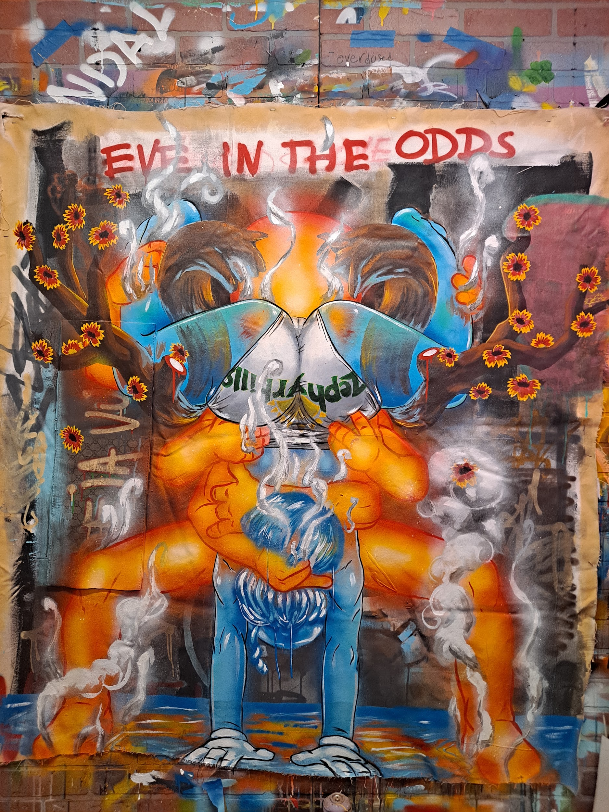Eve In The Odds
53x57
$5400
Call a conscience decision a conscience decision. She came to my roots and asked for the blooms of my labors.
She spoke of waters so vast it wraps its
tides around the dome of the firmament. Her story carries the most common Ms.Conception.
But he knew by putting Eve in the odds it
would even the odds.
Even souls born polar opposites lose their moral compass just to meet in the middle.

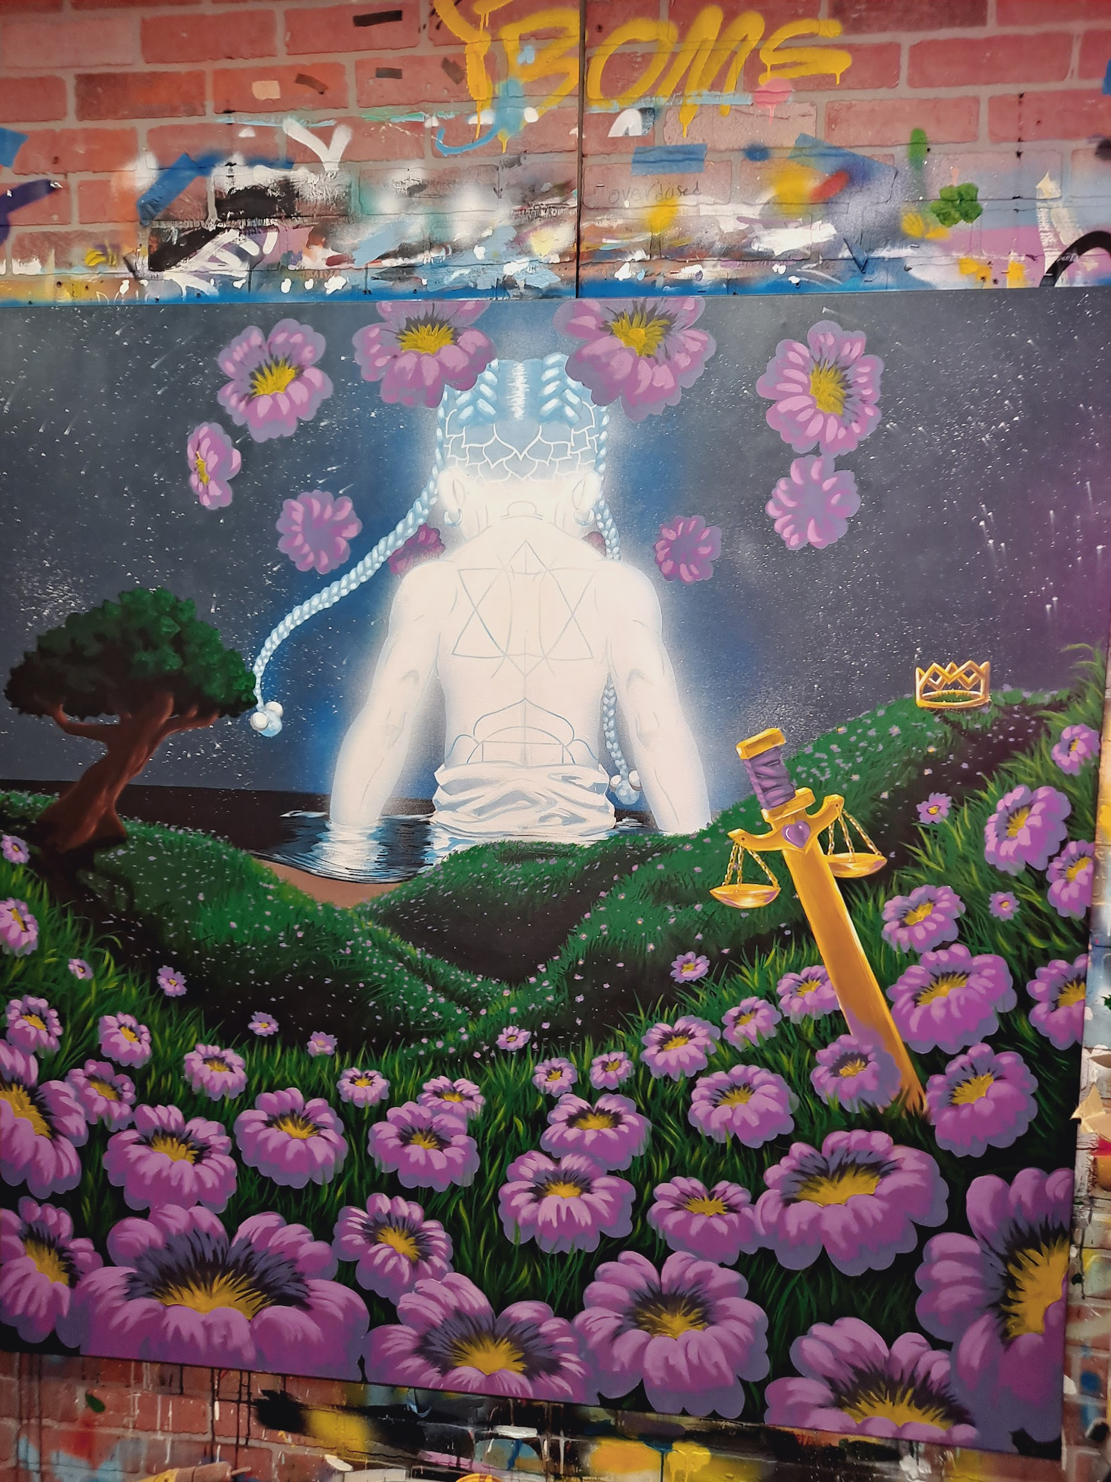Libra Moon
60x60
$8200
Glow as if the night sky depends on you
Rank supersedes matter
sight supersedes eyes
imagination evolves into knowledge

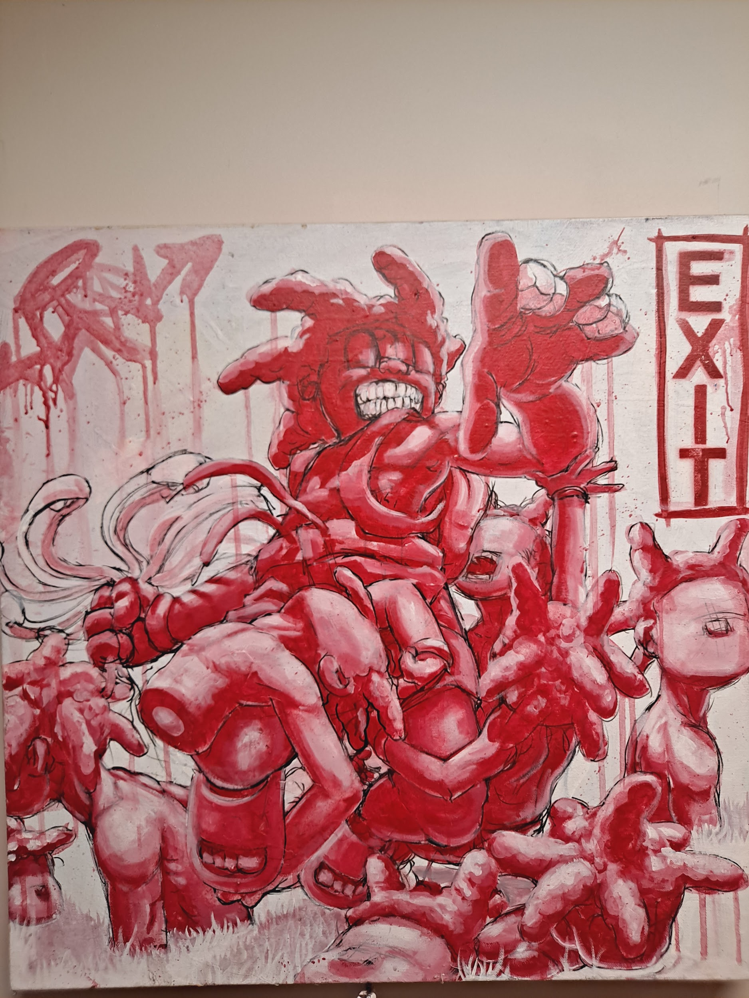
Skill Of David Ego Of Goliath
24x24
$1200

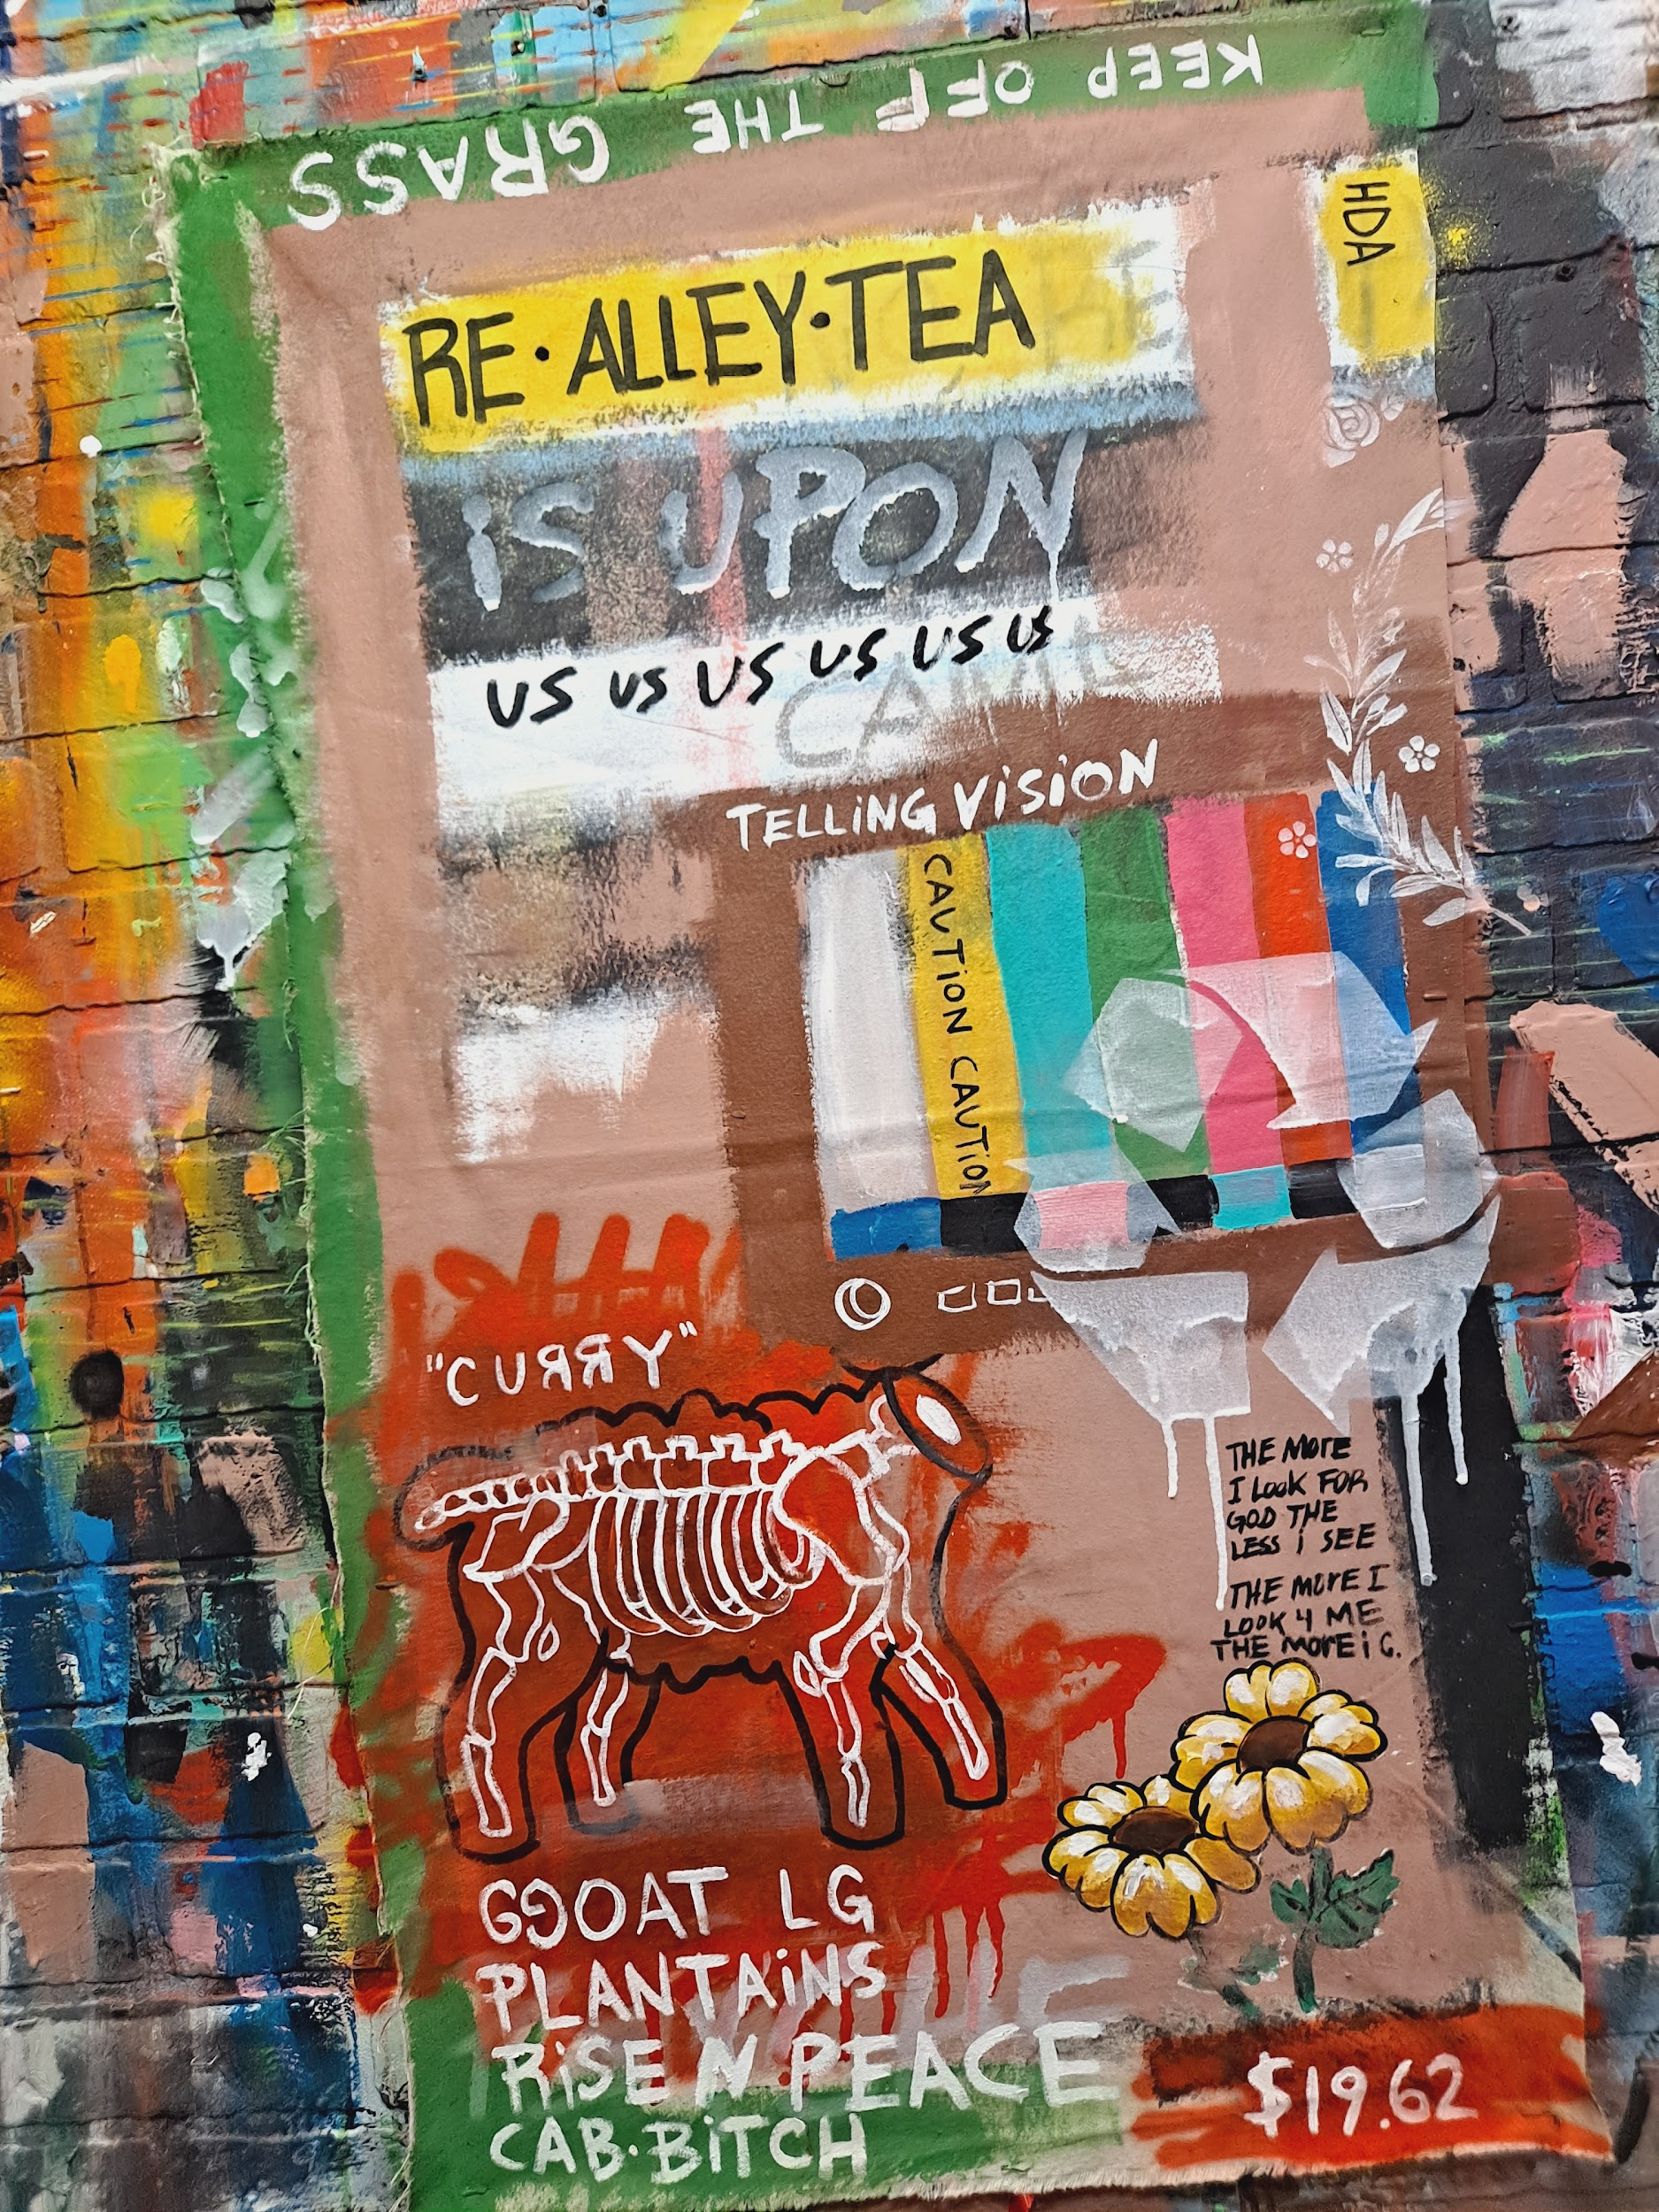
Channeling
22x38
$600

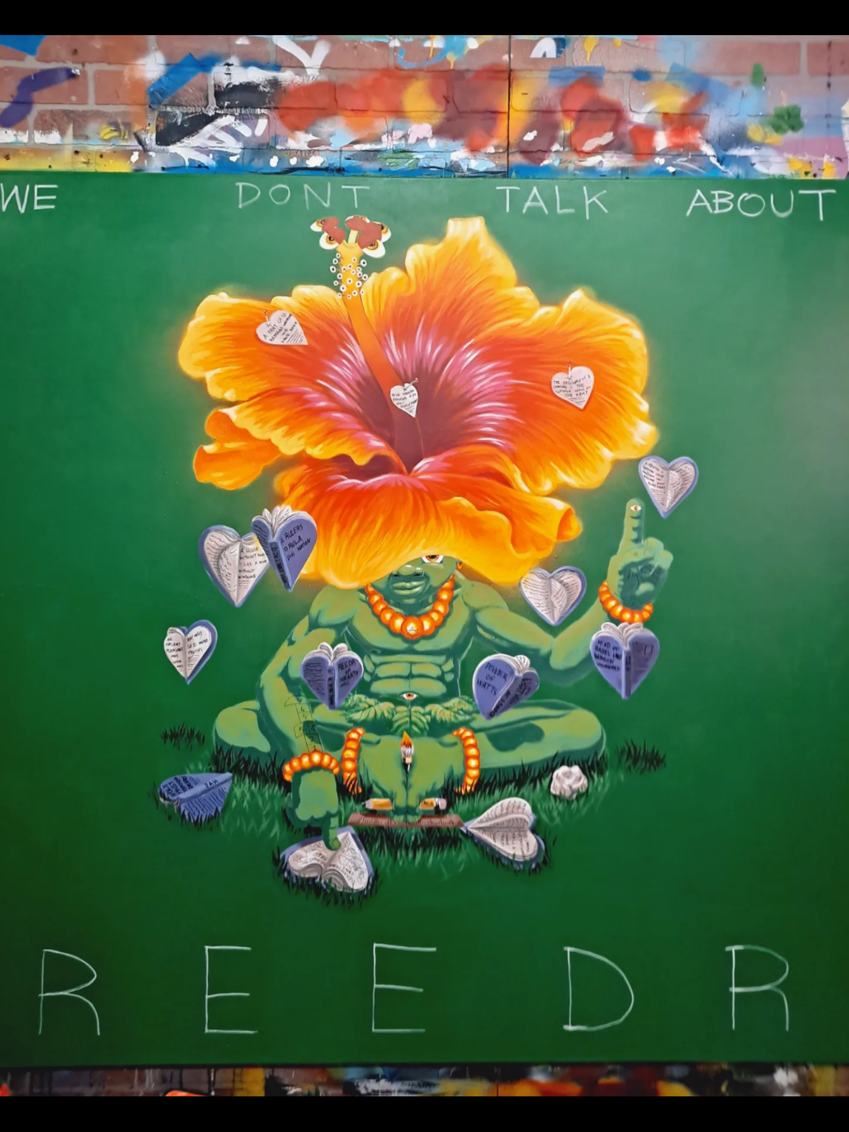
Bearer of Watts
Reedr of Hearts
60x60
$8200
Reedr of Hearts Bearer of Watts - Creative Pinellas

Eye Sis
32x36
$2125

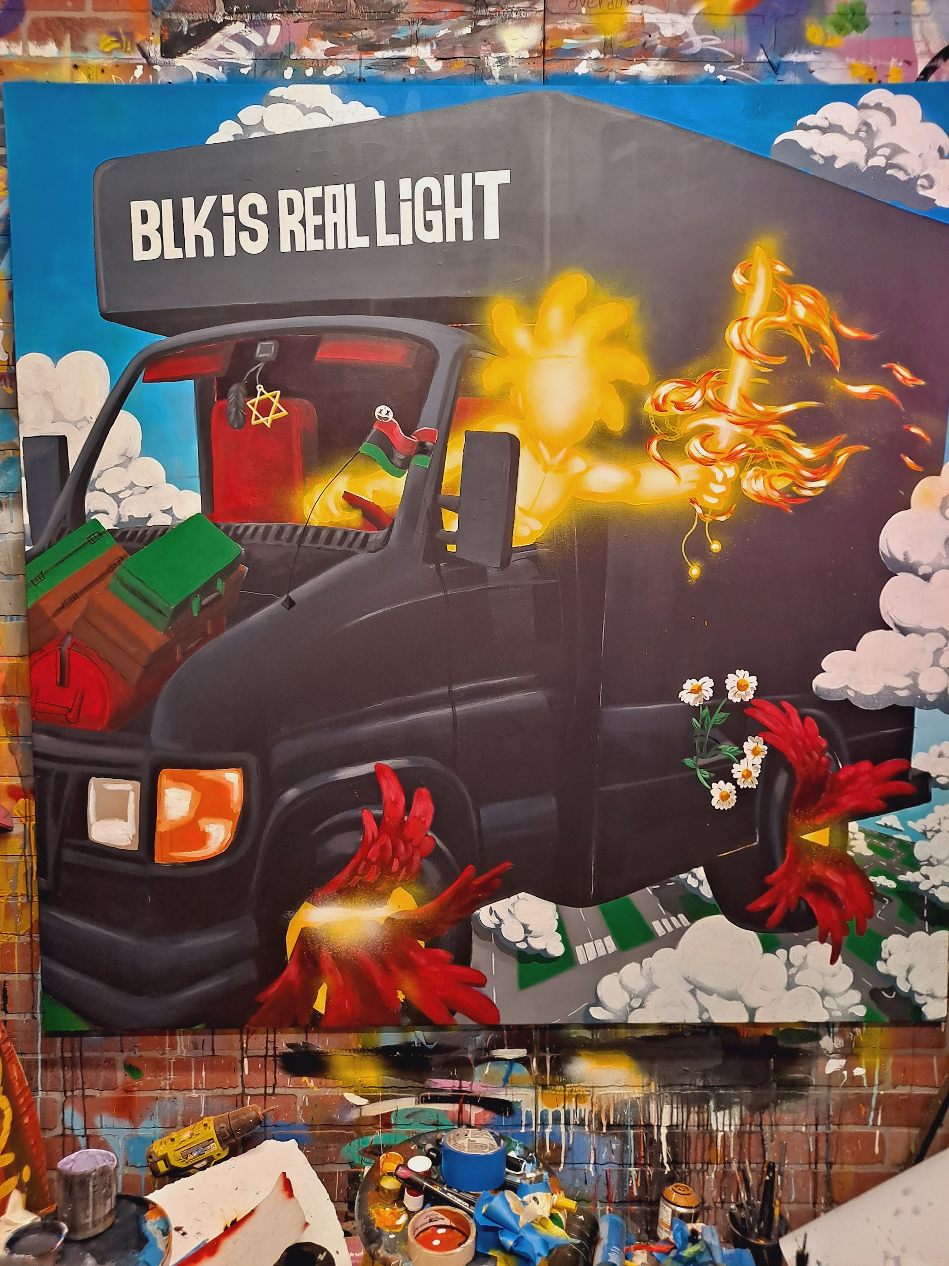
BLK is Real Light
60x60
$8200

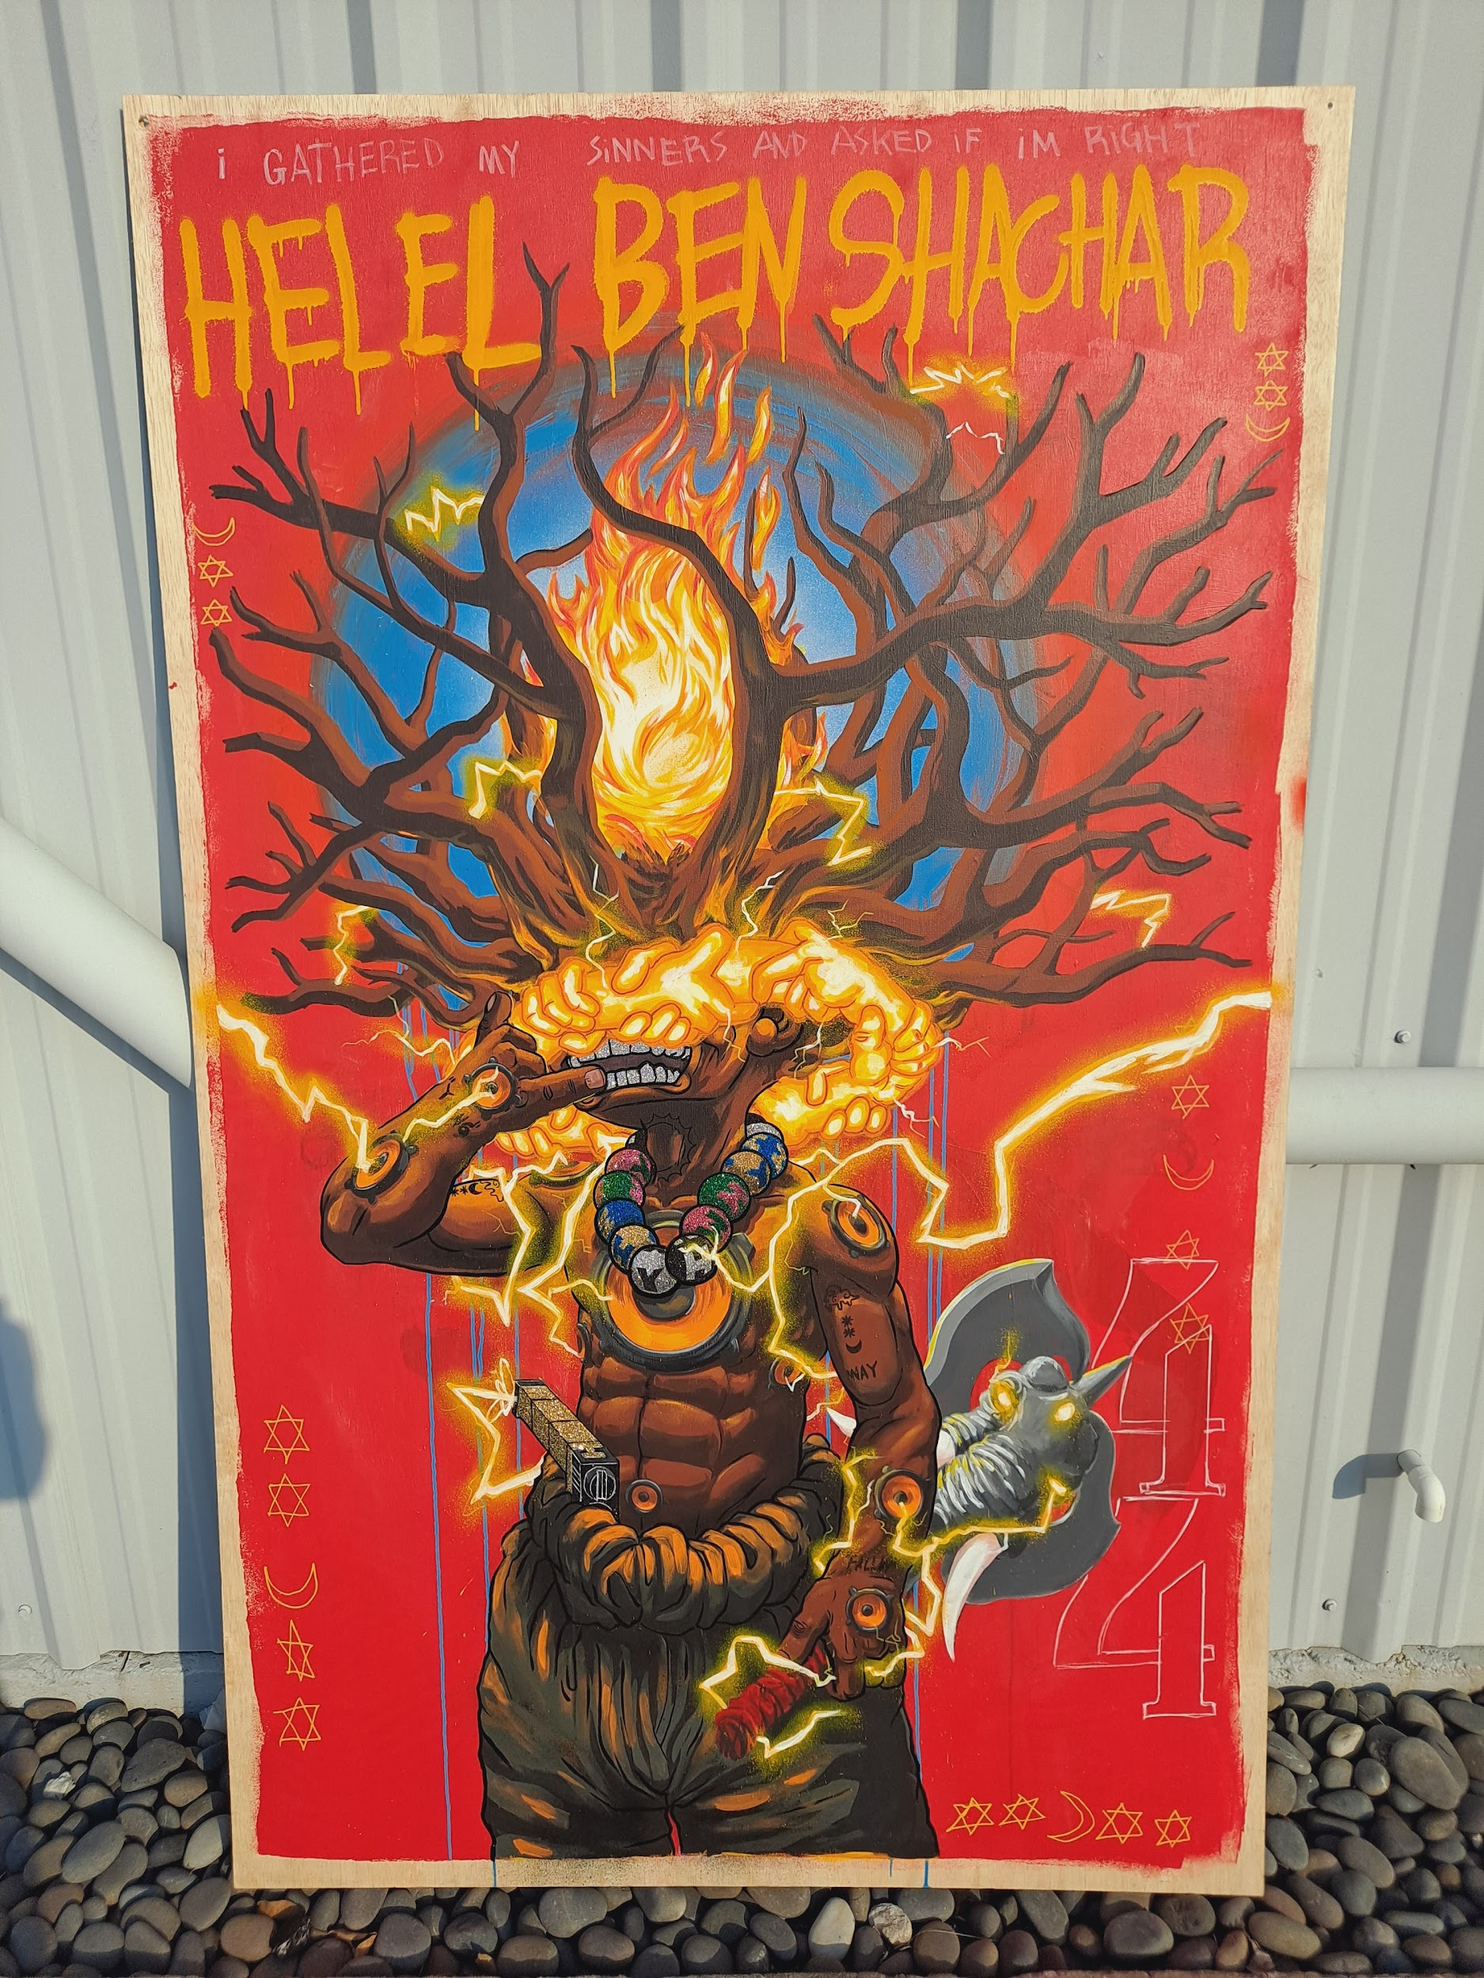ArchAngel of fire & Light
48x96
$8200
Arc Angel of Fire and Light
Bestowed with horned instruments protruding from his body much like the pipes of an organ. He casted symphonies of protection around God’s throne. Leading the Celeste Scheels in the mighty is praise to the most high. Base vibrations from his hearts subwoofers Quick the window panes of the heavens.
With its sunshine state of mind Only the light bringer can understand the realms of darkness in the most intimate ways. For it is his duty To illuminate the darkest corners of the universe. Let there be light whispered through time when he was birthed. What we believe to be evil is the very source making it bright enough for us to see the threats in the shadow.

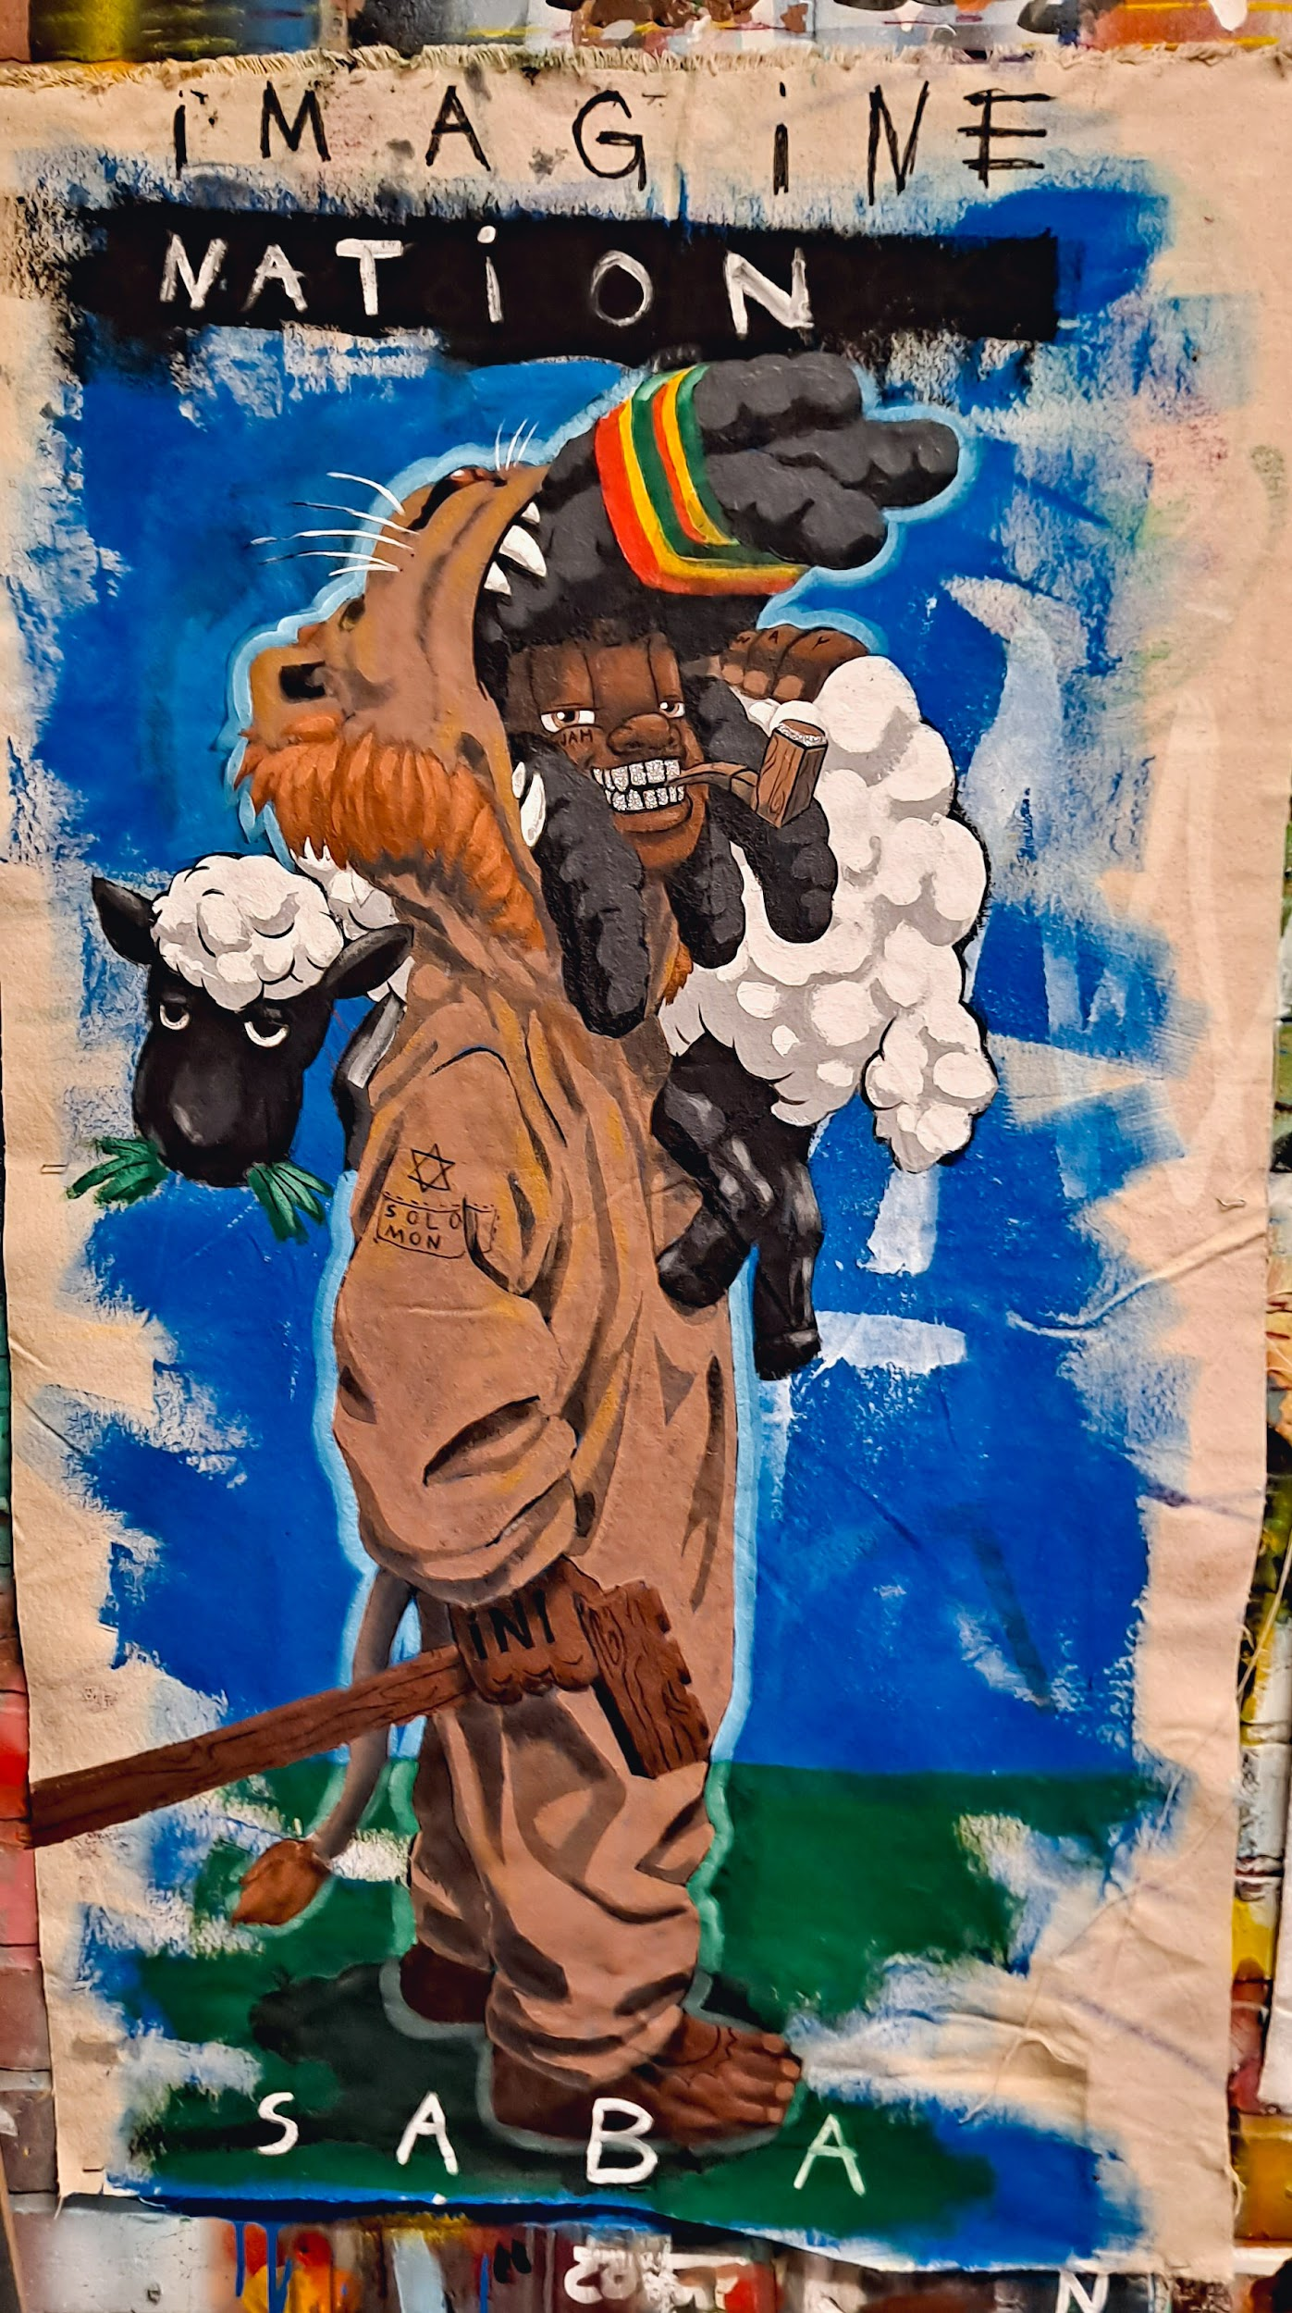
LeoNarco Da Vèvès (The Last Maroons)
"Cub of Judah" (Rastas & Shottas)
23x40
$1825

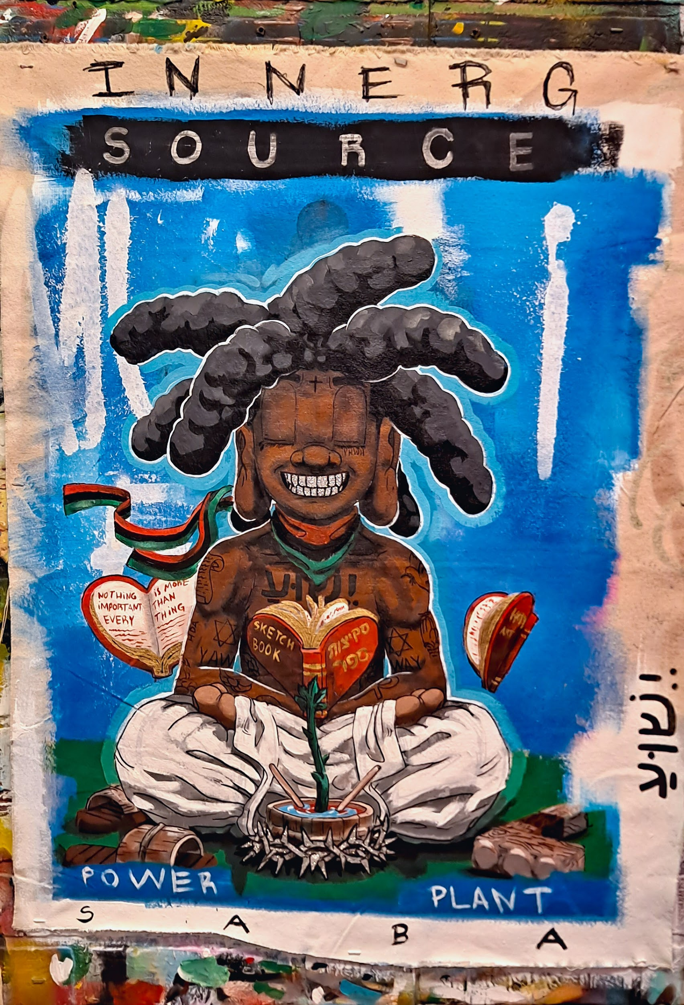LeoNarco Da Vèvès (The Last Maroons)
"Yeshuaquavius" (The Aloof Buddha)
23x31
$1600

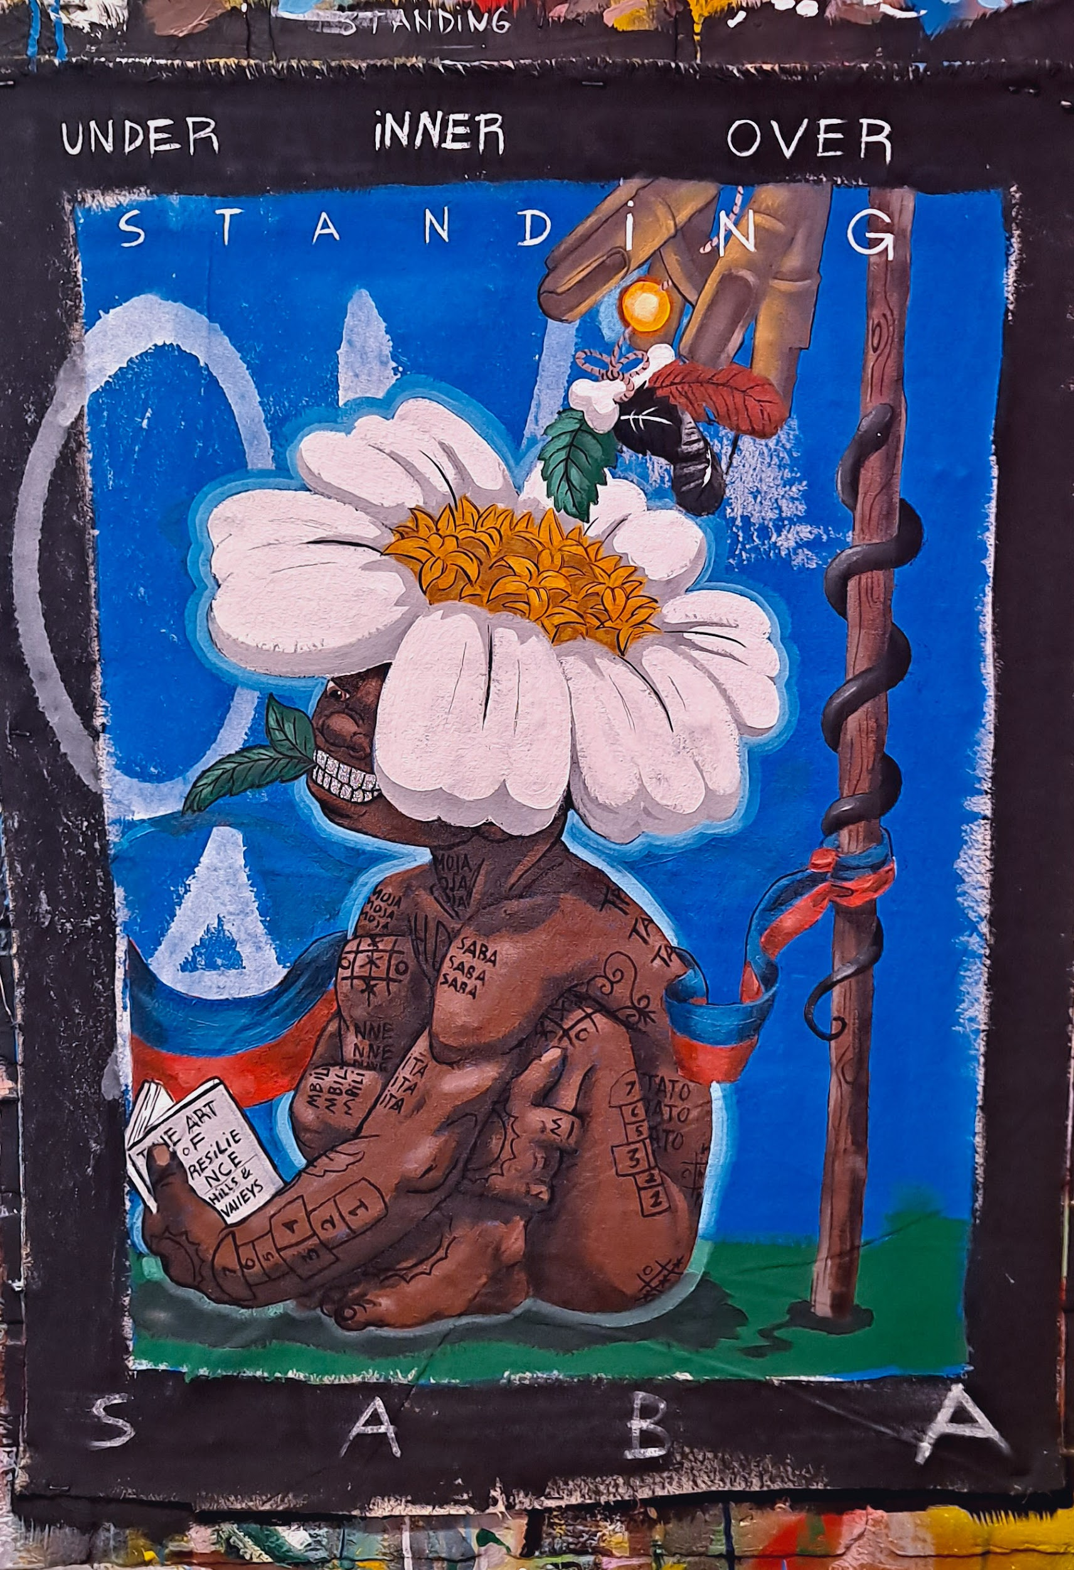LeoNarco Da Vèvès (The Last Maroons)
"Makandal Moses" (The First Ougan)
21x28
$1600

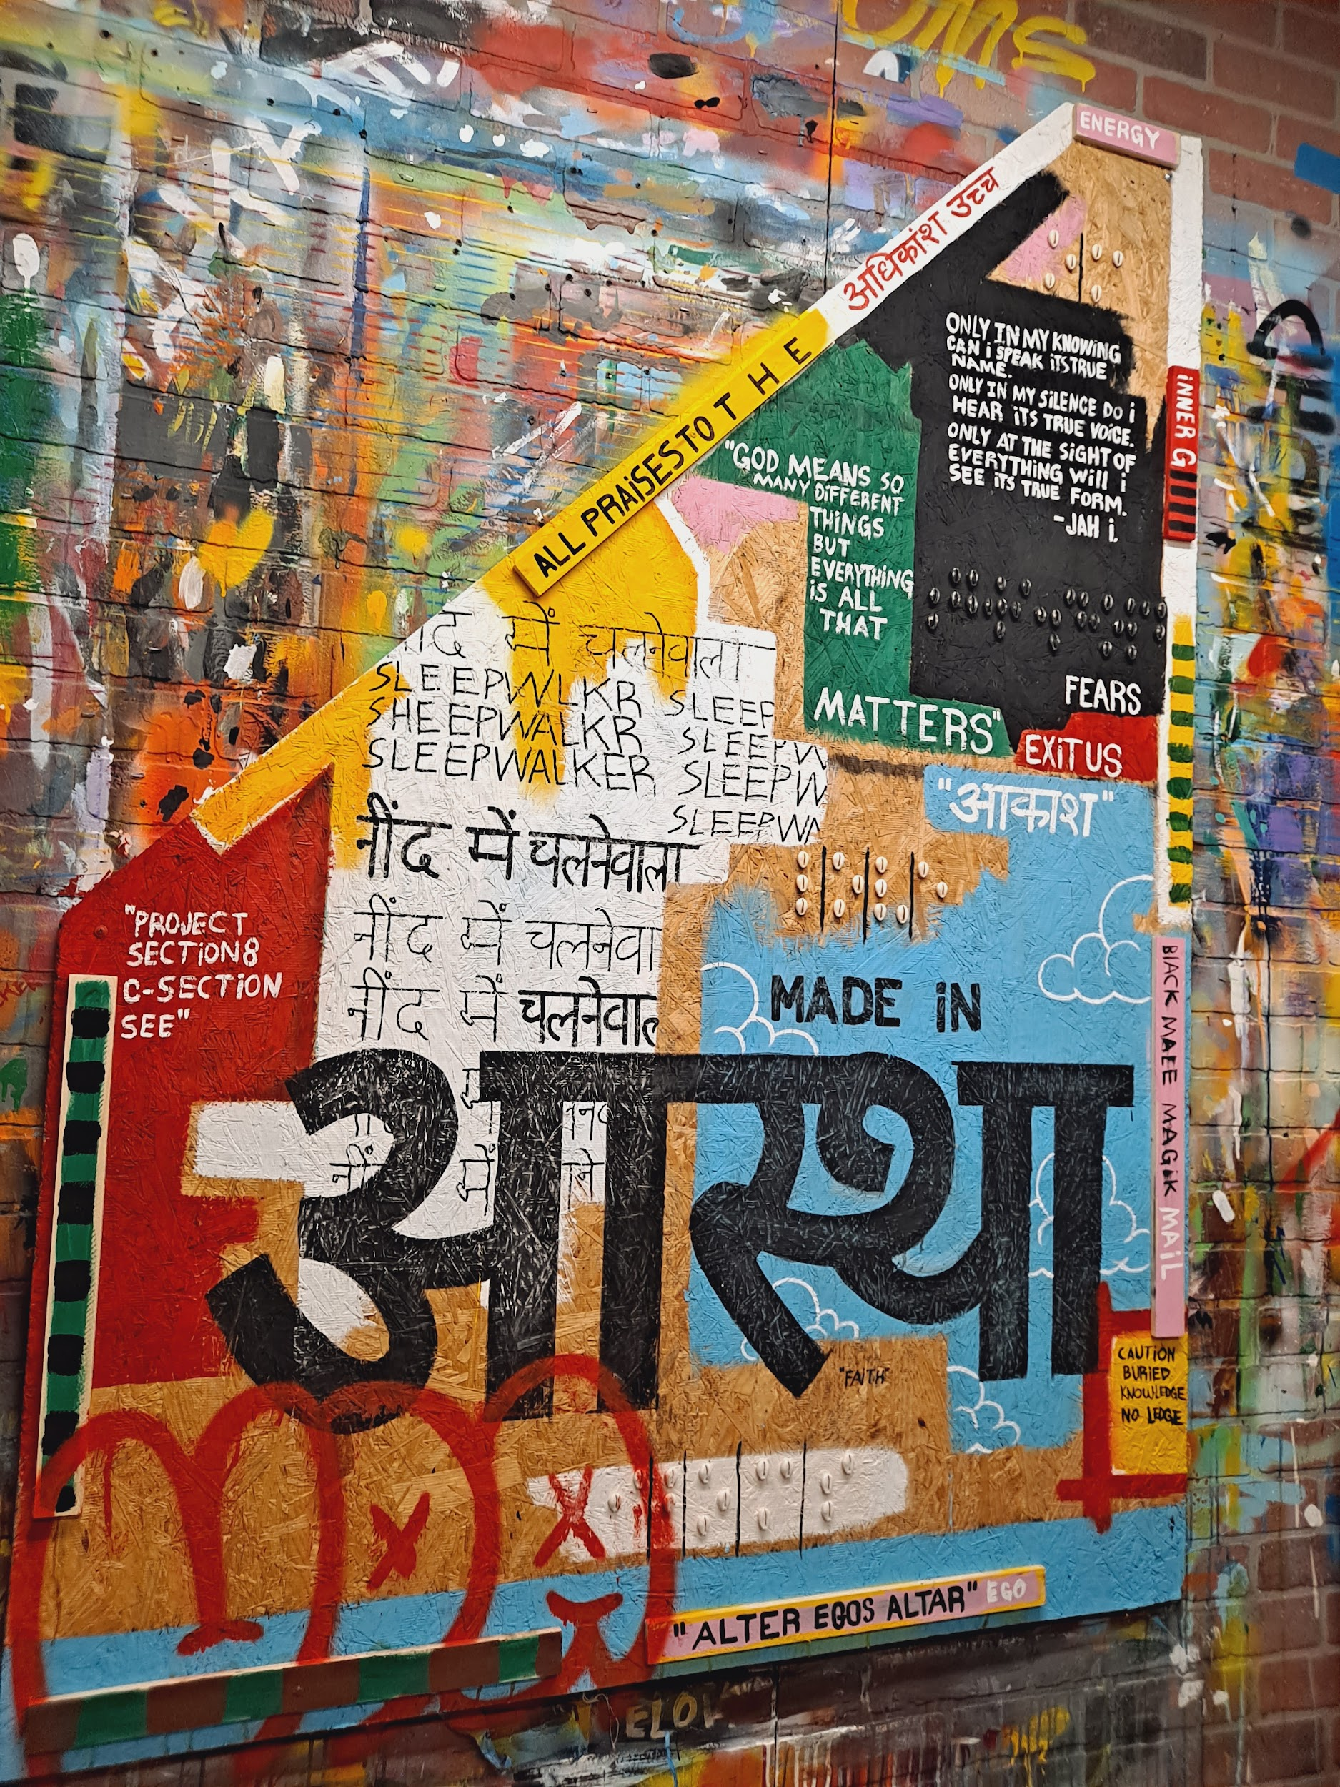
Bass Keys & Yatchs
48x68
$3200
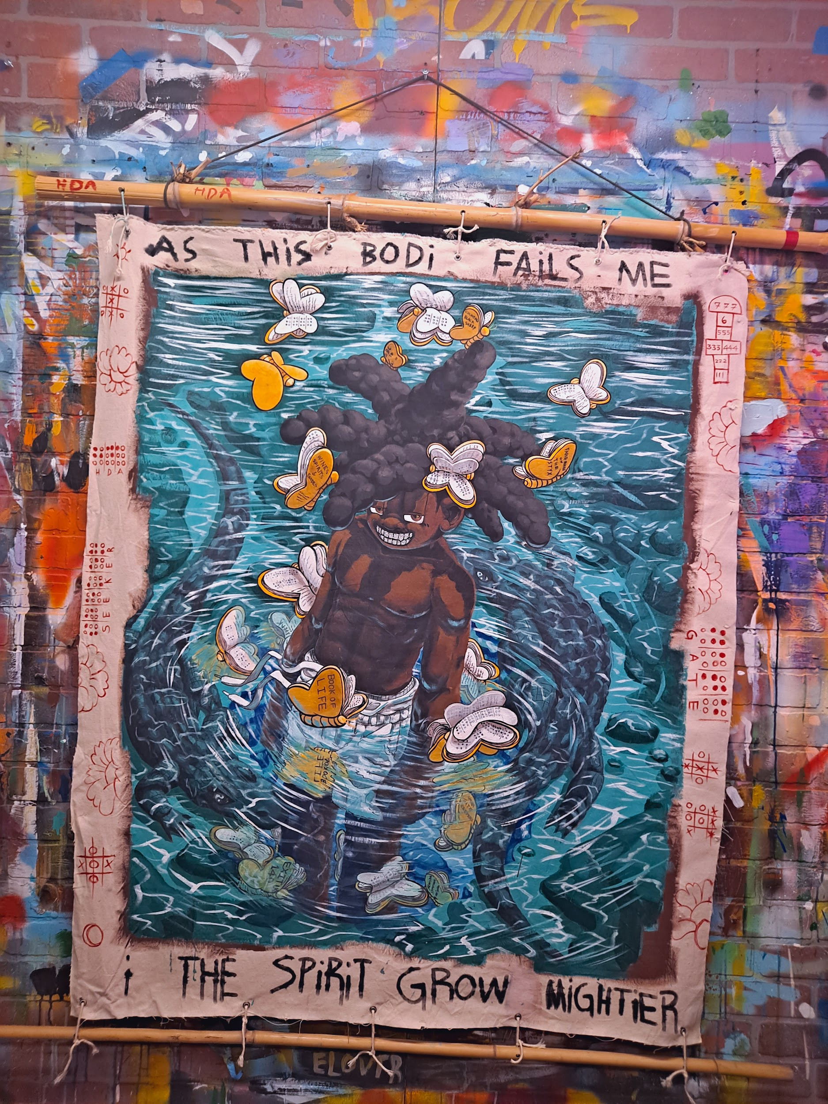
F.S.U (Florida Shamanic Universe)
43x53
$4125

If I weren't able to vividly visualize what they deemed as crazed hallucinations.
My freedom would surely be in jeopardy.
If I perhaps rambled on corners, the words I sew into my pallets. I'd be covered in citations of the blind.
Contemplating my wrongdoers' contemplations causes burdensome detachments where the fabric once held strong.
Rivers, springs, and lakes seasoned with seasonal souls some kind enough to save us from our own inescapable woes.
The goosebumps their presence ignites can be read like the souls braille

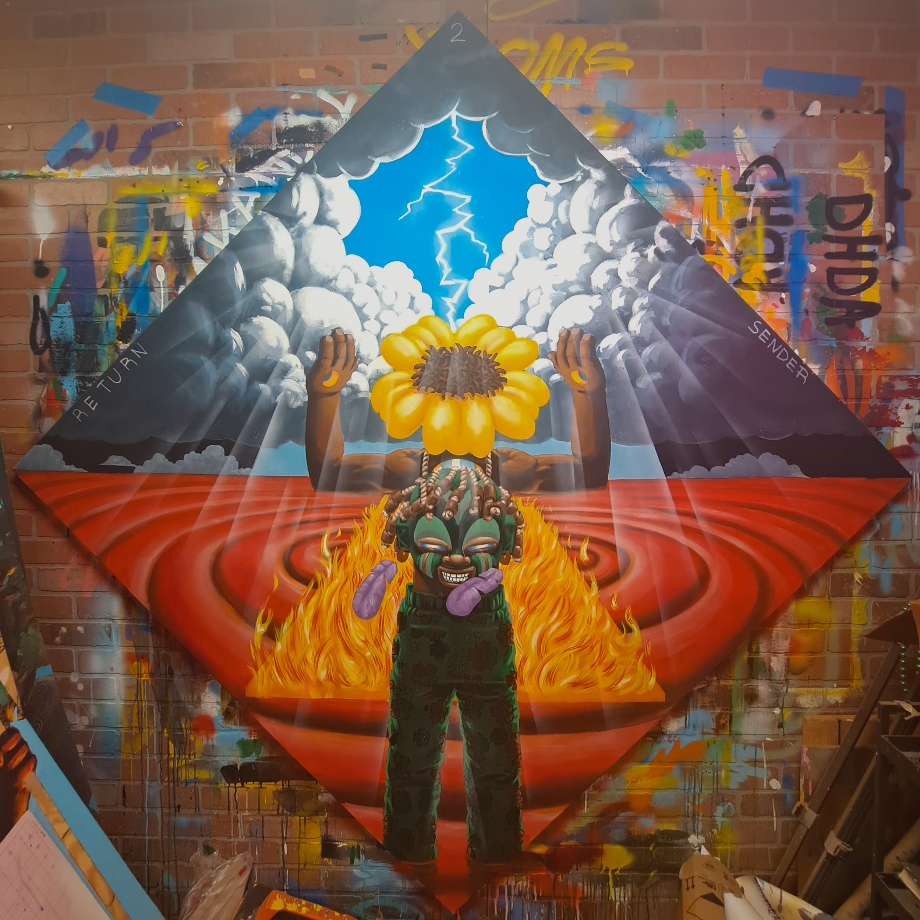Grandsun
60x60
$8200

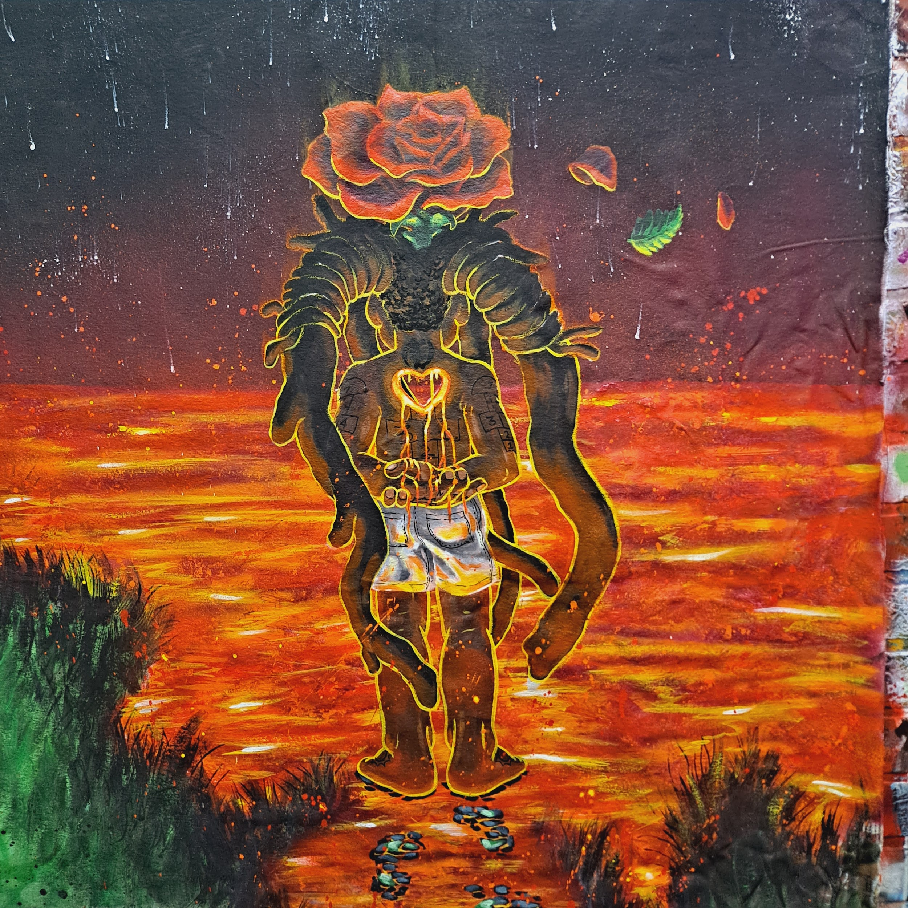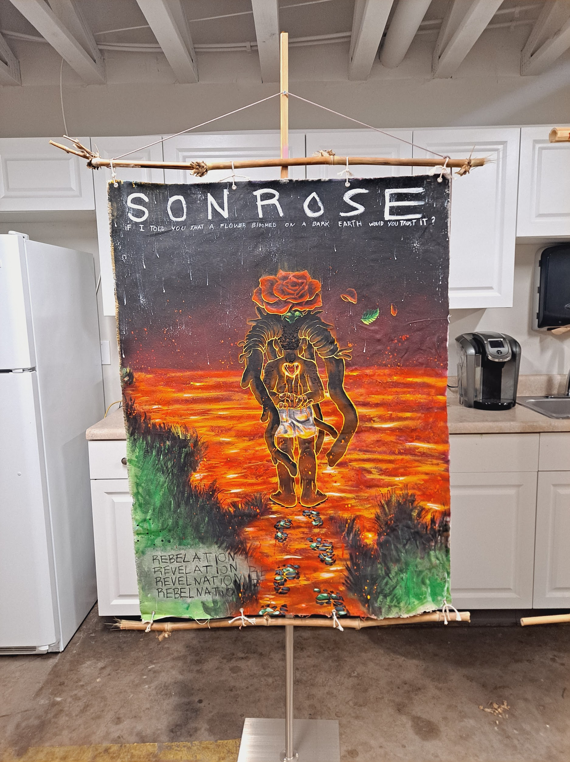
Cerebro
35x47
$3525
Do not go where the path may lead
Go instead where there is no path
And leave a trail.

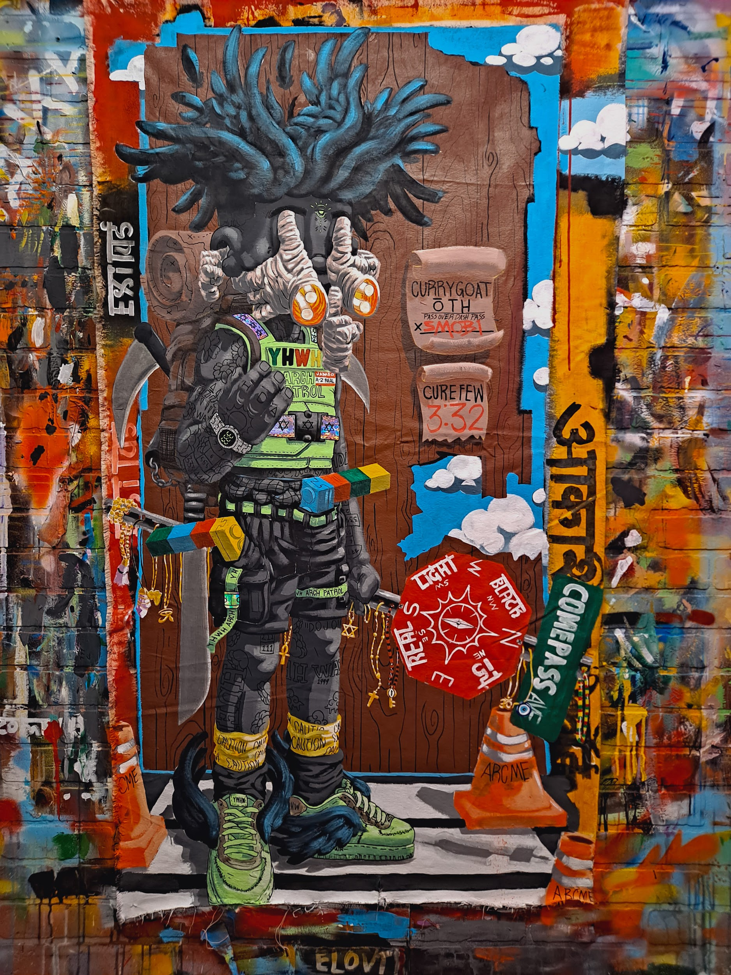
ExitUs
34x60
$4100
In the Hebrew Bible, the destroying angel / death angel, also known as mashḥit, is an entity sent out by YHWH on several occasions to kill the enemies of the Hebrews.
Heaven sent hitmen.

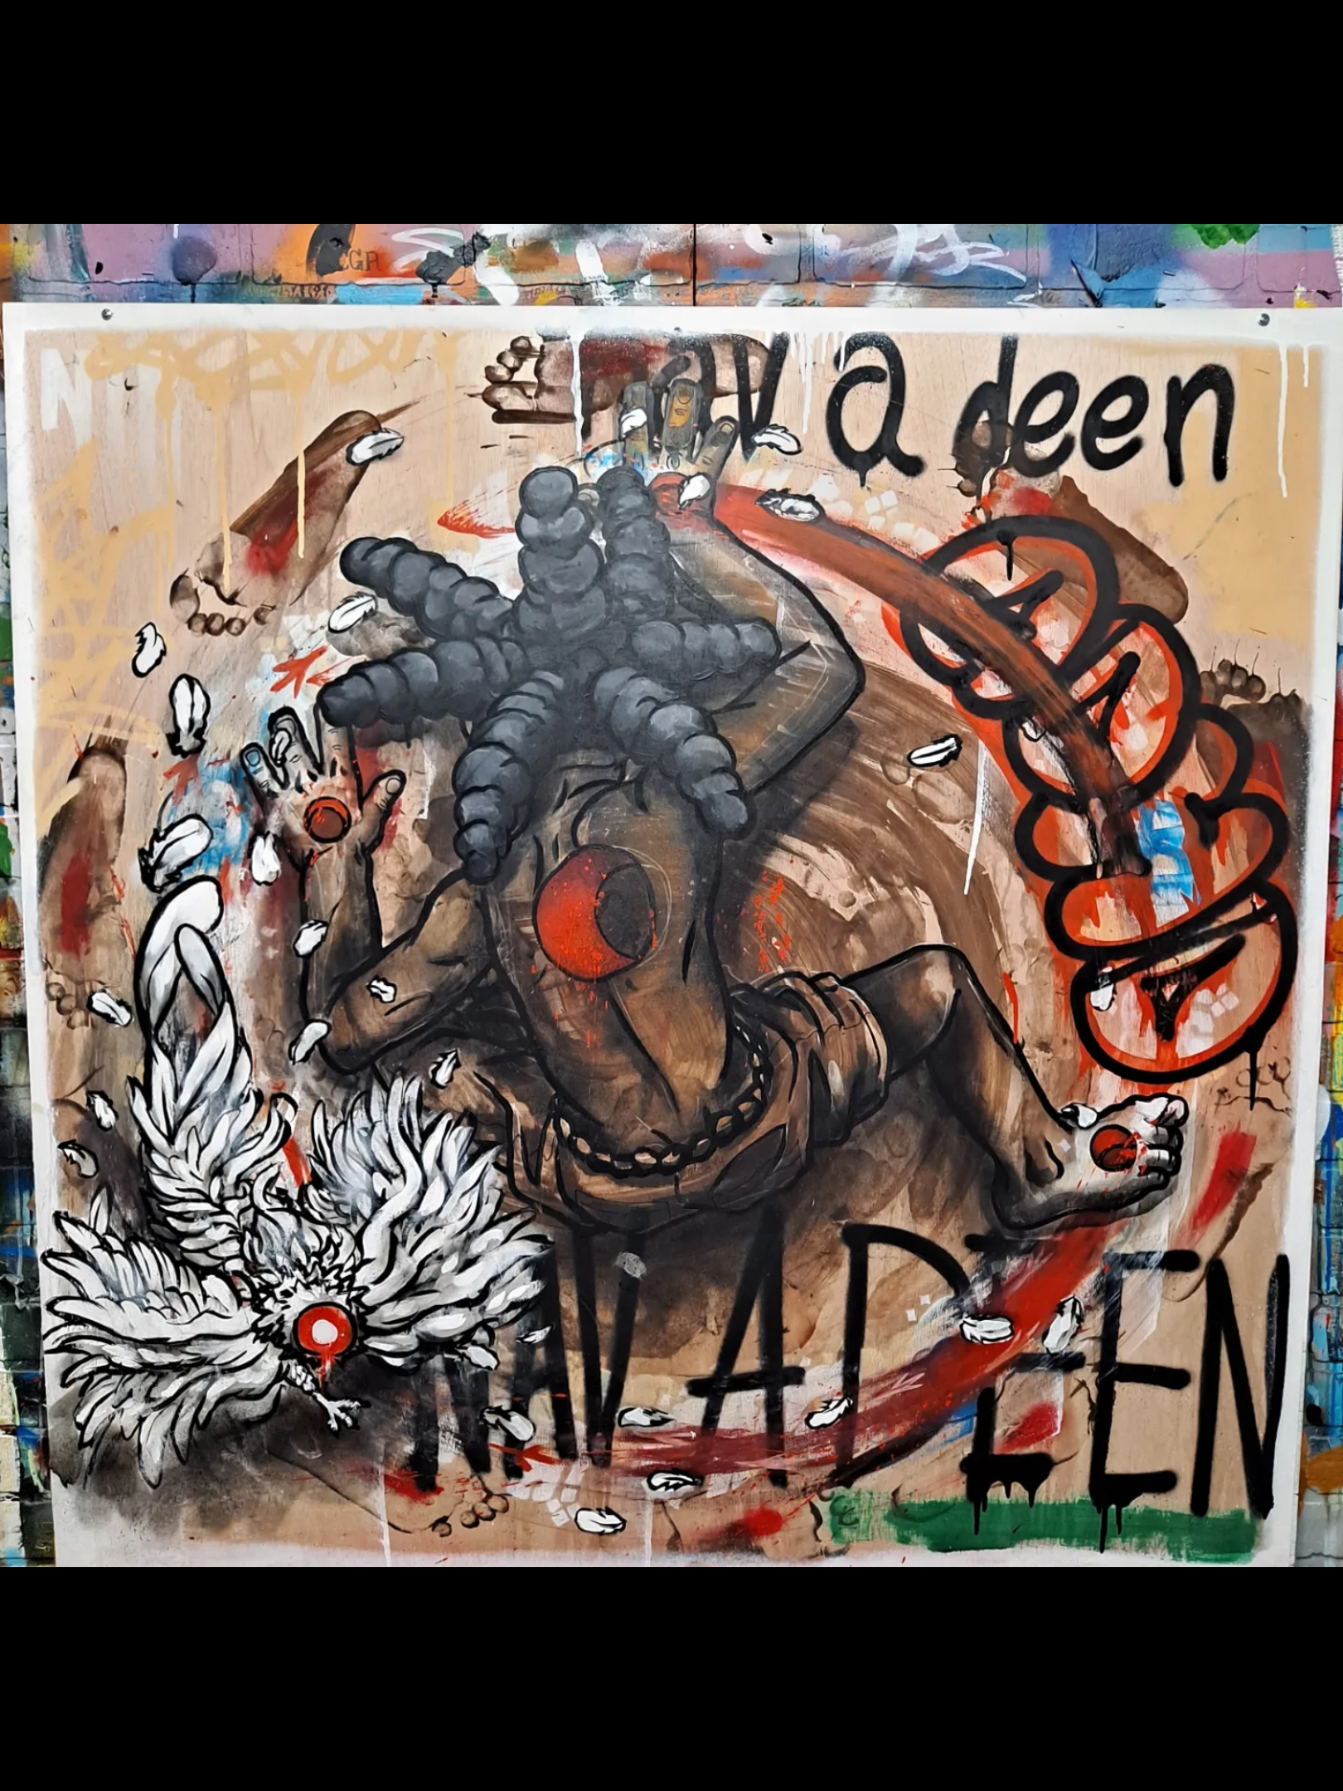
Ebo
48x48
$4125
My rites tell me to write about my rights.
We come bearing visions; they pill us up to hold us down.
What you feel is abnormal. Meaning the way we were designed was not normal. Though the norm never existed amongst the unique, our gifts are still labeled malfunctions by systems of the bleak.

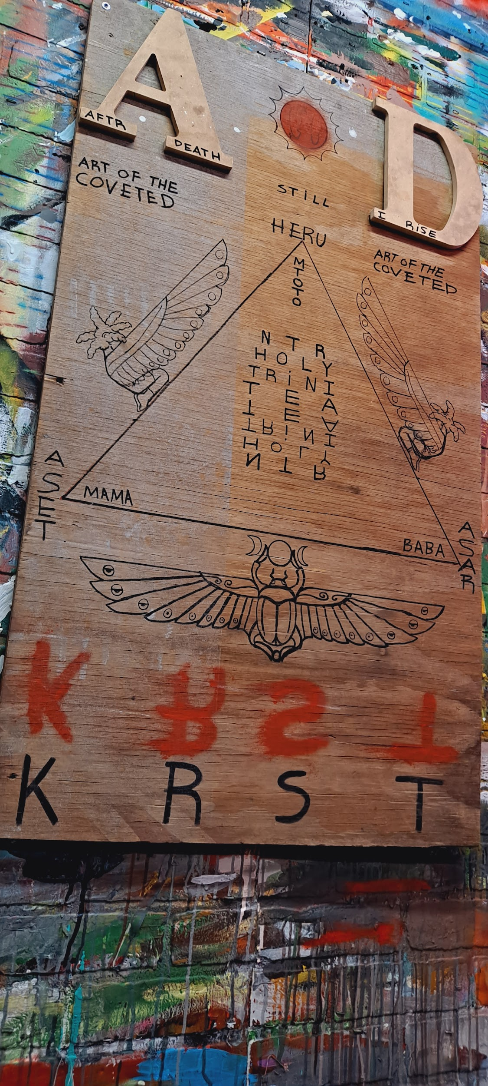
Holy Trini Tea
24x41
$950
The Egyptian hieroglyph KRST (christos,christ) meaning the anointed one,
was a title applied to the deity Heru (Horus) later crucified, he was born to Aset (Isis) and Asar(Osiris), creating one of the first concepts of the holy trinity. Later changed to the father, the son, and the holy ghost.
Seemingly excluding the importance of the divine feminines role in giving life.
Krst was the kemetic idea of change and transformation physically and / or metaphorically into the highest version of self for a soul incarnated into this earthly realm.

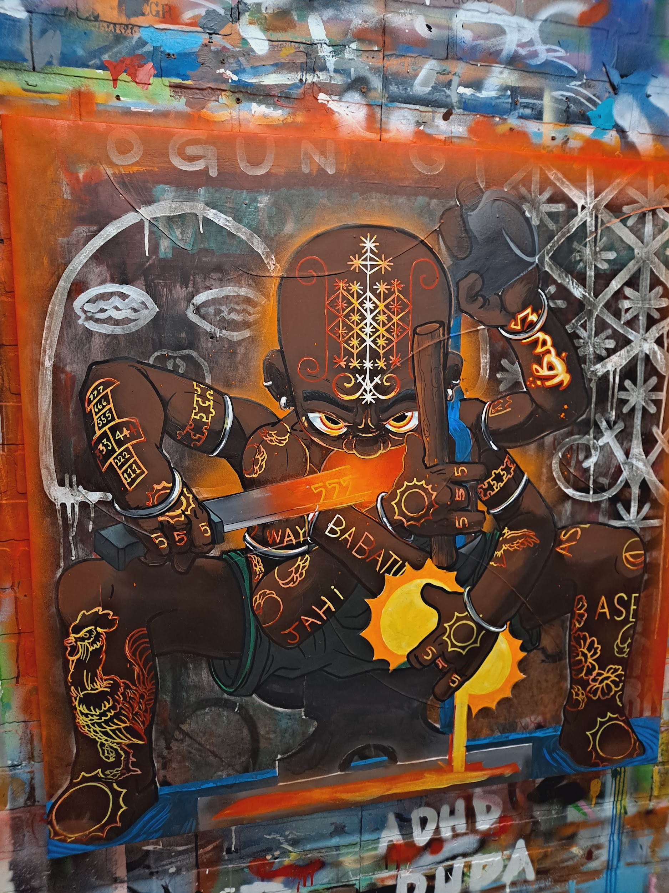
IFÁ Ruled the World (Ogun)
39x39
$3525

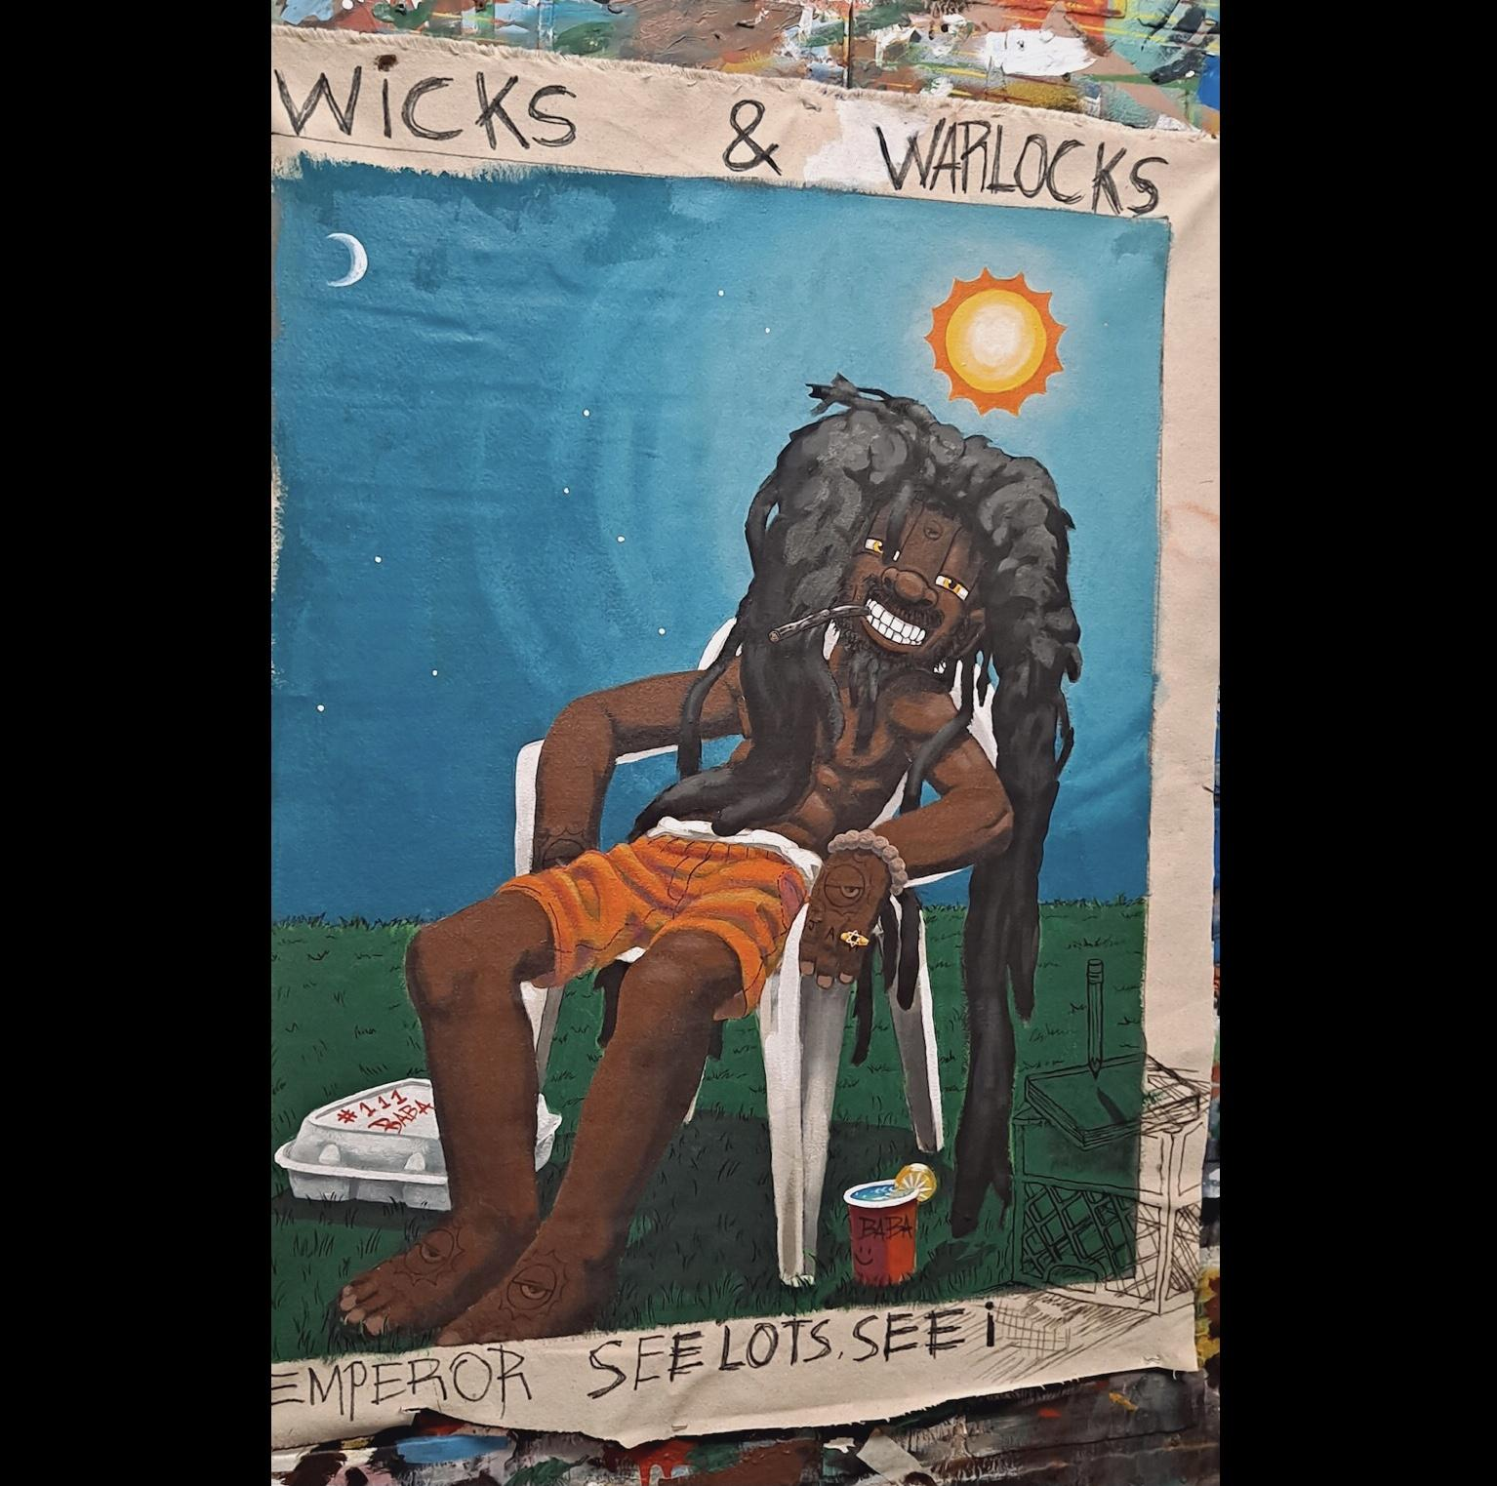
Emperor See Lots See I
28x36
$2000

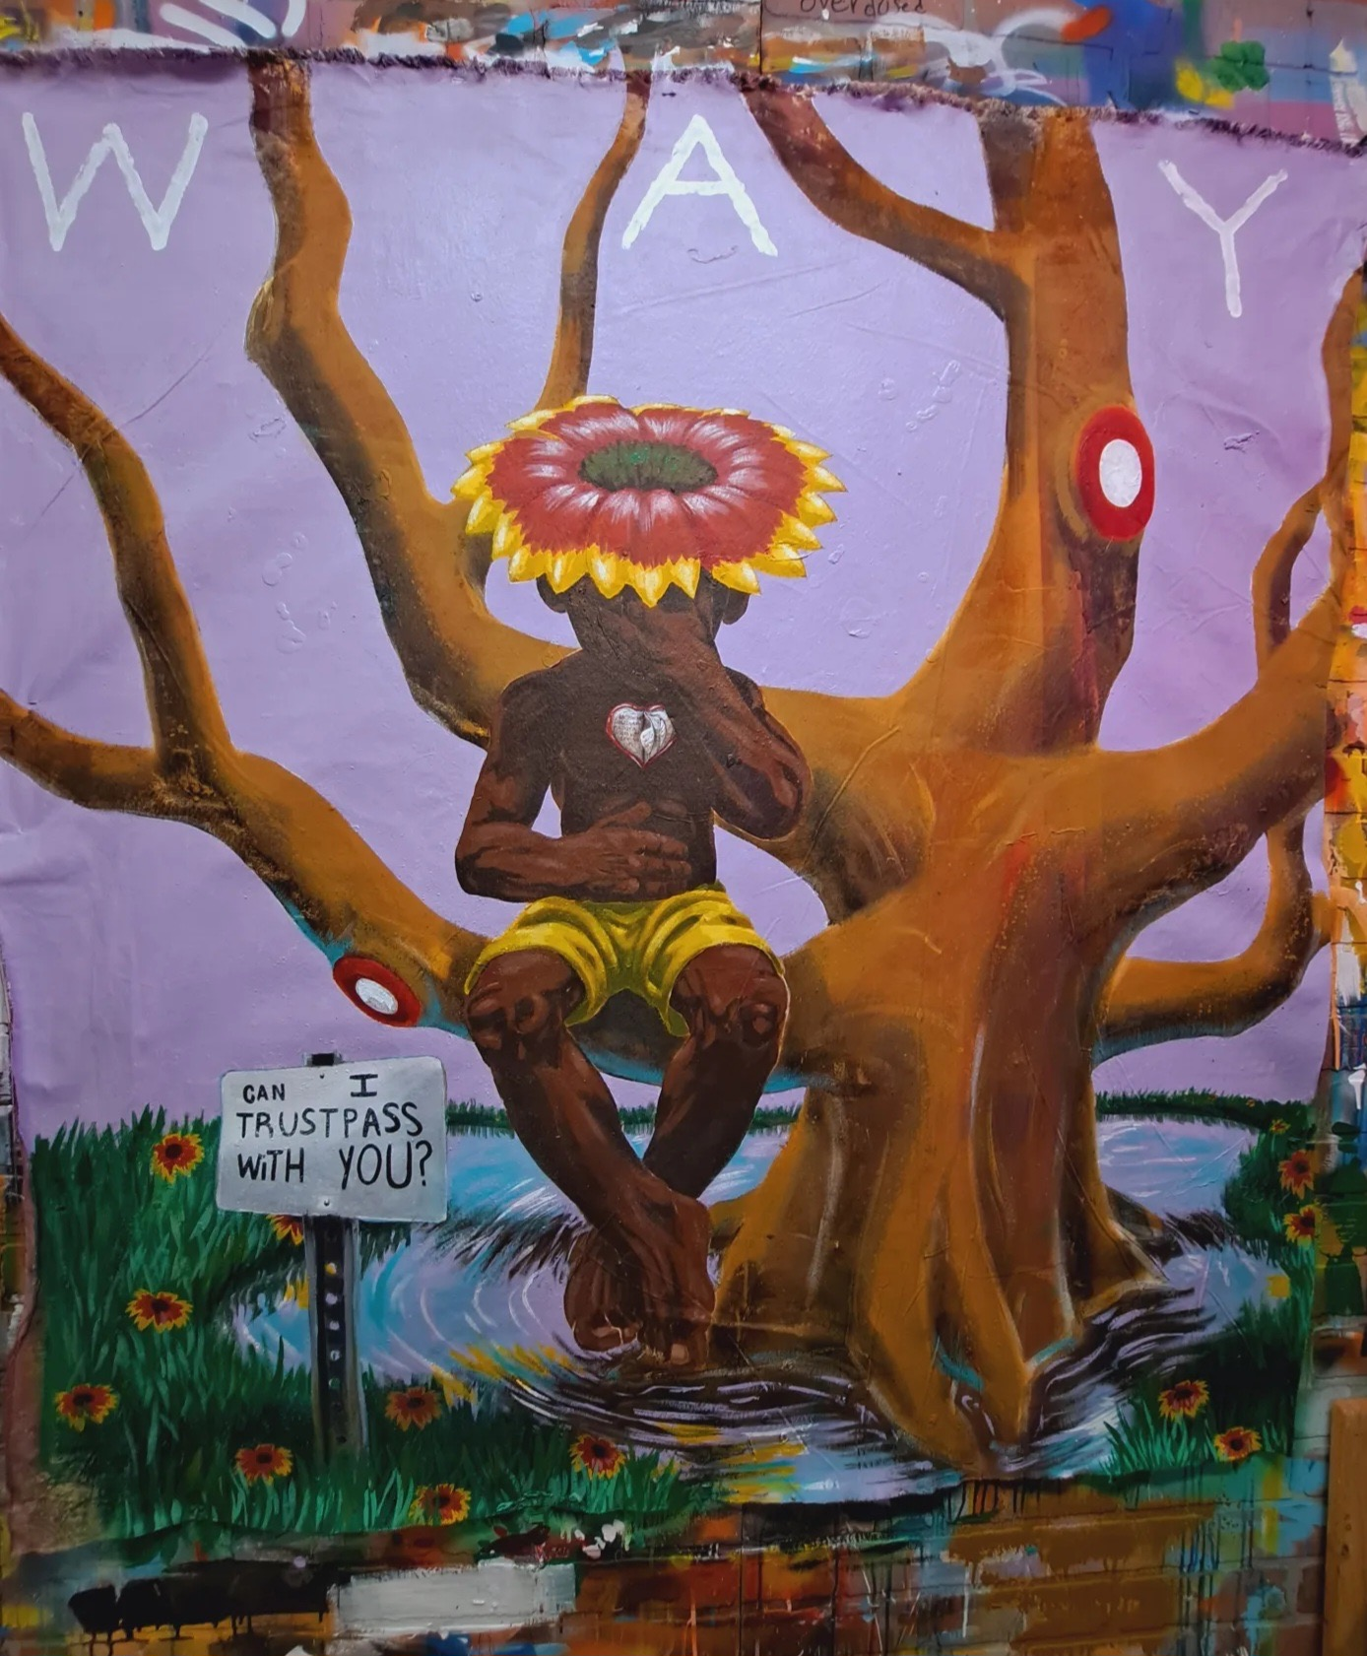
Trails of Sean
48x54
$5200
Read more

All raw canvas pieces are in scroll format bamboo support bars.🙏🏾😁🫶🏽✊🏾‼️
Intro to iBOMS - Creative Pinellas
